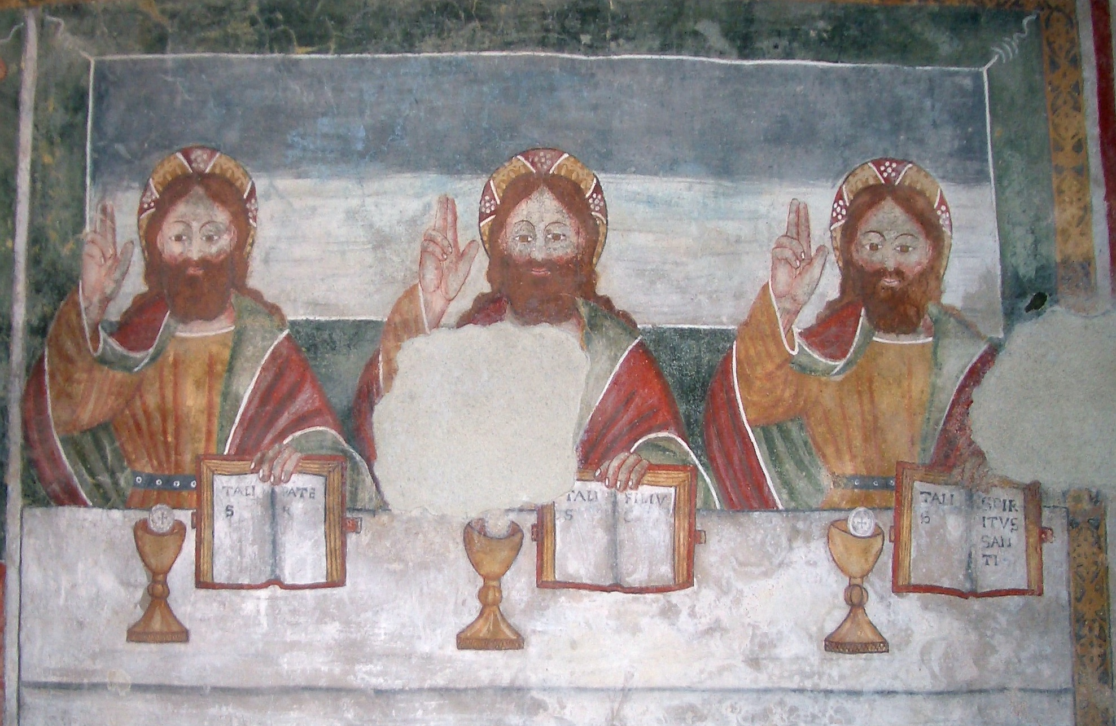
St Alfege Church Greenwich - Music for the month of June 2021

Picture of the month: Trinity, 15th-century fresco, Castelletto Cervo (Vercelli, Italy), St Peter and St. Paul Church
 | Hymns | Introit & Mass | Anthem | Music during the administration
6 June 10.00 am  Trinity 1  Corpus Christi | 66 (vv 1, 2, 6 and 7), 336 (vv 1, 4 and 5) | Mass in 4 parts – Byrd  (Gloria, Sanctus and Agnus Dei) | Let all mortal flesh keep silence - Bairstow | Ave verum - Byrd  O sacrum convivium - Tallis
13 June 10.00 am  Trinity 2 | 212, 192 (vv 1,2 and 4) | Mass in G minor – Vaughan Williams (Sanctus) | Bring us O Lord God - Harris | Mother of God - Tavener  Justorum animae - Stanford
20 June 10.00 am  Trinity 3 | 126 (vv 1, 2, 5 and 6), 131 (Love Divine vv 1, 2, 3 and 6) | Darke in F  (Sanctus) | A new song - McMillan | O salutaris - Elgar  Now the God of peace - Knight
27 June 10.00 am  Trinity 4  SS Peter & Paul | *133 (omit**) 115 (vv1, 4,5) *207  532 (vv 1,2,4) | Gloria, Creed, Agnus Dei - *Merbecke  Missa tu es Petrus – Palestrina  (Sanctus) | Gospel response:  Tu es Petrus - Duruflé  Anthem:  Jehova quam multi sunt hostes mei – Purcell | Tu es Petrus – Pearsall  In Paradisum from Requiem - Duruflé
*Note: these hymns and Merbecke setting will be omitted if restrictions on congregational singing are still in place

