

Sung Eucharist
Safeguarding Sunday/
Second Sunday before Advent
16 November 2025
Welcome to our services of Holy Communion today. Revd Dr Robert Tobin is presiding at 8am and Revd Dr Tati Gutteridge, Curate, at 10am. The St Alfege Church Safeguarding Team is preaching at both services. We will all sing the Kyrie on page 2. We welcome Rory and Arabelle who are being baptized this afternoon and welcome their families and supporters.
Readings
1 John 3: 16-24
Psalm 91: 1-6, 14-16
James 2: 14-26
Matthew 11: 25-30
Hymns
201 Stand up and bless the Lord
How firm a foundation (on page 8 of this sheet)
May this place be one of nurture (tune: Coverdale) (on page 9 of this sheet)
405 O Day of God, draw nigh
Collect
Heavenly Father, whose blessed Son was revealed to destroy the works of the devil and to make us the children of God and heirs of eternal life: grant that we, having this hope, may purify ourselves even as he is pure; that when he shall appear in power and great glory we may be made like him in his eternal and glorious kingdom; where he is alive and reigns with you, in the unity of the Holy Spirit, one God, now and for ever. Amen
Prayer after Communion
Gracious Lord, in this holy sacrament you give substance to our hope: bring us at the last to that fullness of life for which we long;
through Jesus Christ our Saviour. Amen
Kyrie
Please join in singing the Kyrie from Schubert’s German Mass.
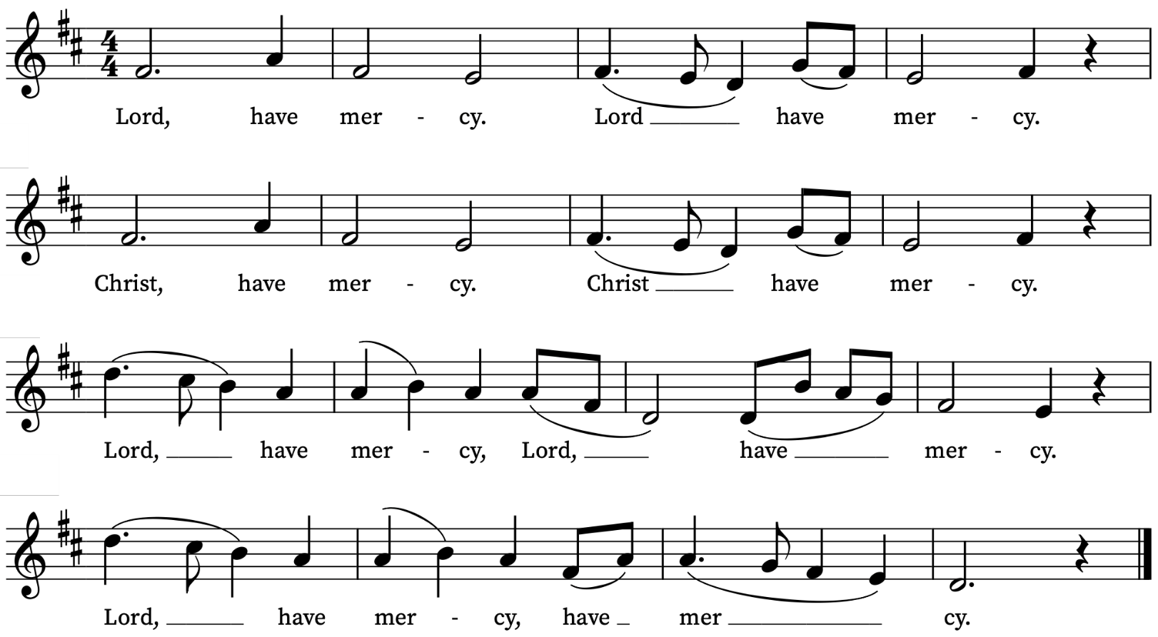

First Reading
1 John 3: 16-24
A reading from the First Letter of John
We know love by this, that he laid down his life for us—and we ought to lay down our lives for one another. How does God’s love abide in anyone who has the world’s goods and sees a brother or sister in need and yet refuses help?
Little children, let us love, not in word or speech, but in truth and action. And by this we will know that we are from the truth and will reassure our hearts before him whenever our hearts condemn us; for God is greater than our hearts, and he knows everything. Beloved, if our hearts do not condemn us, we have boldness before God; and we receive from him whatever we ask, because we obey his commandments and do what pleases him.
And this is his commandment, that we should believe in the name of his Son Jesus Christ and love one another, just as he has commanded us. All who obey his commandments abide in him, and he abides in them. And by this we know that he abides in us, by the Spirit that he has given us.
This is the Word of the Lord
Thanks be to God

Psalm 91: 1-6 and 14-16
Qui habitat
Whoso dwelleth under the defence of the most High : shall abide under the shadow of the Almighty.
2 I will say unto the Lord, Thou art my hope, and my strong hold : my God, in him will I trust.
3 For he shall deliver thee from the snare of the hunter : and from the noisome pestilence.
4 He shall defend thee under his wings, and thou shalt be safe under his feathers : his faithfulness and truth shall be thy shield and buckler.
5 Thou shalt not be afraid for any terror by night: nor for the arrow that flieth by day;
6 For the pestilence that walketh in darkness : nor for the sickness that destroyeth in the noon-day.
14 Because he hath set his love upon me, therefore will I deliver him : I will set him up, because he hath known my Name.
15 He shall call upon me, and I will hear him : yea, I am with him in trouble; I will deliver him, and bring him to honour.
16 With long life will I satisfy him : and shew him my salvation.

Second Reading
James 2: 14-26
A reading from the Letter of James
What good is it, my brothers and sisters, if you say you have faith but do not have works? Can faith save you? If a brother or sister is naked and lacks daily food, and one of you says to them, ‘Go in peace; keep warm and eat your fill’, and yet you do not supply their bodily needs, what is the good of that? So faith by itself, if it has no works, is dead.
But someone will say, ‘You have faith and I have works.’ Show me your faith without works, and I by my works will show you my faith. You believe that God is one; you do well. Even the demons believe—and shudder. Do you want to be shown, you senseless person, that faith without works is barren? Was not our ancestor Abraham justified by works when he offered his son Isaac on the altar? You see that faith was active along with his works, and faith was brought to completion by the works. Thus the scripture was fulfilled that says, ‘Abraham believed God, and it was reckoned to him as righteousness’, and he was called the friend of God. You see that a person is justified by works and not by faith alone. Likewise, was not Rahab the prostitute also justified by works when she welcomed the messengers and sent them out by another road? For just as the body without the spirit is dead, so faith without works is also dead.
This is the Word of the Lord
Thanks be to God

Gospel
Matthew 11: 25-30
Hear the Gospel of our Lord Jesus Christ according to Matthew
Glory be to thee, O Lord
At that time Jesus said, ‘I thank you, Father, Lord of heaven and earth, because you have hidden these things from the wise and the intelligent and have revealed them to infants; yes, Father, for such was your gracious will. All things have been handed over to me by my Father; and no one knows the Son except the Father, and no one knows the Father except the Son and anyone to whom the Son chooses to reveal him.
‘Come to me, all you that are weary and are carrying heavy burdens, and I will give you rest. Take my yoke upon you, and learn from me; for I am gentle and humble in heart, and you will find rest for your souls. For my yoke is easy, and my burden is light.’
This is the Gospel of the Lord
Praise be to thee, O Christ

Today’s Music
Mass setting
Gloria, Sanctus/Benedictus and Agnus Dei from Communion Service in F – Harold Darke
Anthem
Never weather beaten sail – Charles Wood
Never weather beaten sail more willing bent to shore,
Never tired pilgrim's limbs affected slumber more.
Than my wearied sprite now longs to fly out of my troubled breast:
O come quickly, sweetest Lord, and take my soul to rest!
Ever blooming are the joys of Heaven's high Paradise,
cold age deafs not there our ears nor vapour dims our eyes:
Glory there the sun outshines;
whose beams the blessed only see:
O come quickly, glorious Lord, and raise my sprite to Thee!
Words by Thomas Campion
Communion Motet
Tantum ergo - Brückner
Tantum ergo Sacramentum Veneremur cernui:
Et antiquum Documentum Novo cedat ritui:
Praestet fides supplementum Sensuum defectui.
Down in adoration falling, Lo! the sacred Host we hail,
Lo! o'er ancient forms departing Newer rites of grace prevail;
Faith for all defects supplying, Where the feeble senses fail.
To the everlasting Father, And the Son Who reigns on high
With the Holy Ghost proceeding Forth from Each eternally,
Be salvation, honour, blessing, Might and endless majesty. Amen.
Organ Postlude
March in C, Op. 109 – Francis Jackson

Gradual Hymn
How firm a foundation, ye saints of the Lord,
is laid for your faith in his excellent word;
what more can he say than to you he hath said,
you who unto Jesus for refuge have fled?
Fear not, he is with thee, O be not dismayed;
for he is thy God, and will still give thee aid;
he'll strengthen thee, help thee, and cause thee to stand,
upheld by his righteous, omnipotent hand.
In every condition, in sickness, in health,
in poverty's vale, or abounding in wealth;
at home and abroad, on the land, on the sea,
as thy days may demand shall thy strength ever be.
When through the deep waters he calls thee to go,
the rivers of grief shall not thee overflow;
for he will be with thee in trouble to bless,
and sanctify to thee thy deepest distress.
When through fiery trials thy pathway shall lie,
his grace, all-sufficient shall be thy supply;
the flame shall not hurt thee, his only design
thy dross to consume and thy gold to refine.
The soul that on Jesus has leaned for repose,
he will not, he cannot, desert to its foes;
that soul, though all hell should endeavor to shake,
he never will leave, he will never forsake.
Words: attributed to R. Keen (1787) and George Keith (1787). Tune: Foundation.
Offertory Hymn
May this place be one of nurture
where we all may come to know
how your endless love sustains us
as we live and move and grow.
May we work to build your kingdom
full of truth and light and grace,
living life in all its fullness
held in one divine embrace.
For our negligence and failures
you have called us to repent,
drawing energy for action
from the voices of lament.
As the secret hurts long hidden
may at last be brought to light,
may the truth unlock the freedom
that is every person’s right.
When the smallest child is valued,
and the strong empower the weak,
and each human life is hallowed
and the unheard voices speak:
then your justice stands like mountains
and your mercy falls like rain,
and you hold the brokenhearted
till they learn to live again.
So in gratitude we praise you,
and we lift to you in prayer,
all the people you are calling
to this ministry of care.
Give us wisdom, grace and courage,
holding fast to all that’s good,
seeing Christ in one another
we will love and serve our Lord.
Words: Ally Barrett. Tune: Coverdale
Prayers for the week
We ask God’s blessing on Rory and Arabelle who are being baptized in Church this afternoon.
We pray for those in need: Aminta and Anthony, Fran Barlow, Ian Clark, Helen and Dan Delap, Jo Fortheringham, Karen Hansen, Hessie and Nick Hervey, Glynne and Nancy John, Lena Kimming, James Markham, Lylian Meira, Tony Othen, Vinubhai Patel, Eva Preisich, Jessica Springbett, Jean Smith, Tina Stanley, Jessica Tipton, Sabrina Unold, George Voelker, Drew Webster, Pauline Youll, and Joshua Zitha.
We remember those who have died recently, including Gordon Anderson, Martin Burgess, Revd Canon David Driscoll, John Driver, Mike Jeans, Catherine Varney, Barbara Veale and David Weaver. We also remember Karen Ann Cann and Valerie Jean Naylor on their year’s mind. We ask God’s blessing and comfort on all mourning the loss of loved ones.
To include names of loved ones on the prayer list, please contact David McEvoy dmcevoy@btinternet.com
A prayer for the Holy Land
Gracious Father, whose blessed Son Jesus Christ came down from heaven to be the true bread which gives life to the world: In your mercy, provide for all those in Gaza and beyond who suffer from hunger and starvation, that they may be given both physical bread to nourish their bodies and heavenly bread to sustain their souls. By the power of your Spirit, bring a speedy end to this cruel war, the release of all captives, care for the sick and wounded, comfort for those who have lost loved-ones, and the opening of a pathway for a just and lasting peace here in the very homeland where your Son, our Lord Jesus Christ, ministered during his earthly life; who lives and reigns with you and the Holy Spirit, one God, now and forever. Amen.
The Most Reverend Dr Hosam E. Naoum, Anglican Archbishop in Jerusalem, August, 2025

Supporting St Alfege Church
Please do make a gift to support the life and ministry of St Alfege Church – during the collection in the service or by using a card reader at the North and West Doors. Please complete a Gift Aid envelope (if you are eligible) whether you donate by cash or card. You can also use this QR code to donate. | 

Services this week
Today, Sunday 16 November Safeguarding Sunday
8.00am Holy Communion (Book of Common Prayer)
10.00am Sung Eucharist
2.30pm Baptism of Rory and Arabelle
Monday 17 November
8.30am Morning Prayer
Tuesday 18 November
8.30am Morning Prayer
Wednesday 19 November
8.30am Morning Prayer
Thursday 20 November
8.00am Holy Communion
Sunday 23 November Christ the King
8.00am Holy Communion (Book of Common Prayer)
10.00am Sung Eucharist
Walk-In Wednesdays
Every Wednesday 10am-12noon in the Frank Smith Room in the hall.
Contact Us
Vicar: Revd Simon Winn
Curate: Revd Dr Tati Gutteridge
Church Office: 020 8853 0687
email: office@st-alfege.org.uk www.st-alfege.org.uk
Safeguarding Team
Karen Hansen Lead Safeguarding Officer 07866 932 894
Carole Moses Safeguarding Officer 07889 396 671
Irene Bishop Safeguarding Officer 020 8698 2658
safeguarding@st-alfege.org.uk

