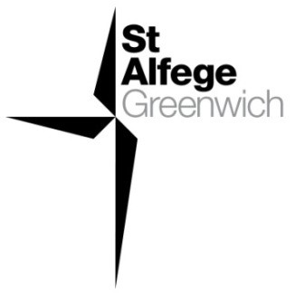

Sung Eucharist
Christ the King/
Sunday next before Advent
23 November 2025
Welcome to our services of Holy Communion today. Revd Simon Winn, Vicar, is presiding at 8am and 10am. David McEvoy, Reader, is preaching at both services. Revd Tati is leading the 11am service at the Old Royal Naval College Chapel. We all sing the Kyrie on page 2.
Readings
Jeremiah 23: 1-6
Psalm 46
Colossians 1: 11-20
Luke 23: 33-43
Hymns
147 Crown him with many crowns
148 At the name of Jesus (omit verses 2, 6, 7)
117 Praise to the Holiest in the height (tune Richmond)
(omit verses 4, 5, 6)
345 Christ is the King! O friends rejoice (omit verses 5 and 6)
Collect
Eternal Father, whose Son Jesus Christ ascended to the throne of heaven that he might rule over all things as Lord and King:
keep the Church in the unity of the Spirit and in the bond of peace, and bring the whole created order to worship at his feet;
who is alive and reigns with you, in the unity of the Holy Spirit,
one God, now and for ever. Amen
Prayer after Communion
Stir up, O Lord, the wills of your faithful people; that they, plenteously bringing forth the fruit of good works, may by you be plenteously rewarded; through Jesus Christ our Lord. Amen

Kyrie
Please join in singing the Kyrie from Schubert’s German Mass.
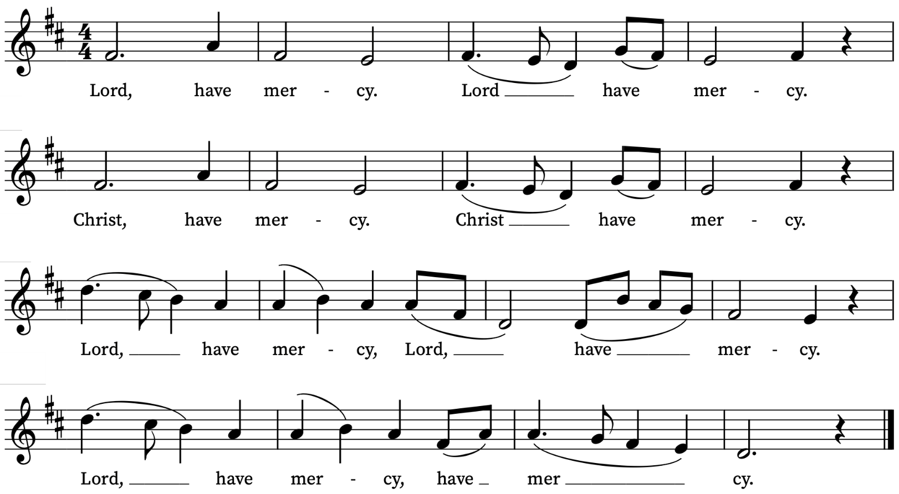
Old Testament Reading
Jeremiah 23: 1-6
A reading from the Prophet Jeremiah
Woe to the shepherds who destroy and scatter the sheep of my pasture! says the Lord. Therefore, thus says the Lord, the God of Israel, concerning the shepherds who shepherd my people: It is you who have scattered my flock, and have driven them away, and you have not attended to them. So I will attend to you for your evil doings, says the Lord. Then I myself will gather the remnant of my flock out of all the lands where I have driven them, and I will bring them back to their fold, and they shall be fruitful and multiply. I will raise up shepherds over them who will shepherd them, and they shall not fear any longer, or be dismayed, nor shall any be missing, says the Lord.
The days are surely coming, says the Lord, when I will raise up for David a righteous Branch, and he shall reign as king and deal wisely, and shall execute justice and righteousness in the land. In his days Judah will be saved and Israel will live in safety. And this is the name by which he will be called: ‘The Lord is our righteousness.’
This is the Word of the Lord
Thanks be to God
Psalm 46
Deus noster refugium
God is our hope and strength : a very present help in trouble.
2 Therefore will we not fear, though the earth be moved : and though the hills be carried into the midst of the sea;
3 Though the waters thereof rage and swell : and though the mountains shake at the tempest of the same.
4 The rivers of the flood thereof shall make glad the city of God : the holy place of the tabernacle of the most Highest.
5 God is in the midst of her, therefore shall she not be removed : God shall help her, and that right early.
6 The heathen make much ado, and the kingdoms are moved : but God hath shewed his voice, and the earth shall melt away.
7 The Lord of hosts is with us : the God of Jacob is our refuge.
8 O come hither, and behold the works of the Lord : what destruction he hath brought upon the earth.
9 He maketh wars to cease in all the world : he breaketh the bow, and knappeth the spear in sunder, and burneth the chariots in the fire.
10 Be still then, and know that I am God : I will be exalted among the heathen, and I will be exalted in the earth.
11 The Lord of hosts is with us : the God of Jacob is our refuge.

New Testament Reading
Colossians 1: 11-20
A reading from the Letter of Paul to the Colossians
May you be made strong with all the strength that comes from his glorious power, and may you be prepared to endure everything with patience, while joyfully giving thanks to the Father, who has enabled you to share in the inheritance of the saints in the light. He has rescued us from the power of darkness and transferred us into the kingdom of his beloved Son, in whom we have redemption, the forgiveness of sins.
He is the image of the invisible God, the firstborn of all creation; for in him all things in heaven and on earth were created, things visible and invisible, whether thrones or dominions or rulers or powers—all things have been created through him and for him. He himself is before all things, and in him all things hold together. He is the head of the body, the church; he is the beginning, the firstborn from the dead, so that he might come to have first place in everything. For in him all the fullness of God was pleased to dwell, and through him God was pleased to reconcile to himself all things, whether on earth or in heaven, by making peace through the blood of his cross.
This is the Word of the Lord
Thanks be to God

Gospel
Luke 23: 33-43
Hear the Gospel of our Lord Jesus Christ according to Luke
Glory be to thee, O Lord
When they came to the place that is called The Skull, they crucified Jesus there with the criminals, one on his right and one on his left. [[Then Jesus said, ‘Father, forgive them; for they do not know what they are doing.’]] And they cast lots to divide his clothing. And the people stood by, watching; but the leaders scoffed at him, saying, ‘He saved others; let him save himself if he is the Messiah of God, his chosen one!’ The soldiers also mocked him, coming up and offering him sour wine, and saying, ‘If you are the King of the Jews, save yourself!’ There was also an inscription over him, ‘This is the King of the Jews.’
One of the criminals who were hanged there kept deriding him and saying, ‘Are you not the Messiah? Save yourself and us!’ But the other rebuked him, saying, ‘Do you not fear God, since you are under the same sentence of condemnation? And we indeed have been condemned justly, for we are getting what we deserve for our deeds, but this man has done nothing wrong.’ Then he said, ‘Jesus, remember me when you come into your kingdom.’ He replied, ‘Truly I tell you, today you will be with me in Paradise.’
This is the Gospel of the Lord
Praise be to thee, O Christ

Today’s Music
Mass setting
Gloria, Sanctus/Benedictus and Agnus Dei from Mass for four voices – Thomas Tallis
Anthem
Let all the world – Ralph Vaughan Williams
Let all the world in every corner sing, my God and King!
The heavens are not too high, his praise may thither fly,
the earth is not too low, his praises there may grow.
Let all the world in every corner sing, my God and King!
Let all the world in every corner sing, my God and King!
The church with psalms must shout, no door can keep them out;
but, above all, the heart must bear the longest part.
Let all the world in every corner sing, my God and King!
Words George Herbert (1593-1633)
Communion
Agnus Dei from Mass for four voices – Thomas Tallis
Organ Postlude
Toccata in C. BWV 564 – J.S. Bach
Supporting St Alfege Church
Please do make a gift to support the life and ministry of St Alfege Church – during the collection in the service or by using a card reader at the North and West Doors. Please complete a Gift Aid envelope (if you are eligible) whether you donate by cash or card. You can also use this QR code to donate. | 

Prayers for the week
We celebrate with and pray for Eleanor Holland who was confirmed by Bishop Martin at Southwark Cathedral yesterday.
We pray for those in need: Aminta and Anthony, Fran Barlow, Ian Clark, Helen and Dan Delap, Andrew Fraser, Jo Fortheringham, Hessie and Nick Hervey, Glynne and Nancy John, Lena Kimming, James Markham, Lylian Meira, Nimal Menon, Tony Othen, Vinubhai Patel, Eva Preisich, Jessica Springbett, Jean Smith, Tina Stanley, Jessica Tipton, Sabrina Unold, George Voelker, Drew Webster, Pauline Youll, and Joshua Zitha.
We remember those who have died recently, including Gordon Anderson, Revd Canon David Driscoll, Dan Iorga, Catherine Varney and David Weaver. We also remember Liz Lloyd on her year’s mind. We ask God’s blessing and comfort on all mourning the loss of loved ones.
To include names of loved ones on the prayer list, please contact David McEvoy dmcevoy@btinternet.com
A prayer for the Holy Land
Gracious Father, whose blessed Son Jesus Christ came down from heaven to be the true bread which gives life to the world: In your mercy, provide for all those in Gaza and beyond who suffer from hunger and starvation, that they may be given both physical bread to nourish their bodies and heavenly bread to sustain their souls. By the power of your Spirit, bring a speedy end to this cruel war, the release of all captives, care for the sick and wounded, comfort for those who have lost loved-ones, and the opening of a pathway for a just and lasting peace here in the very homeland where your Son, our Lord Jesus Christ, ministered during his earthly life; who lives and reigns with you and the Holy Spirit, one God, now and forever. Amen.
The Most Reverend Dr Hosam E. Naoum, Anglican Archbishop in Jerusalem, August, 2025

Services this week
Today, Sunday 23 November Christ the King
8.00am Holy Communion (Book of Common Prayer)
10.00am Sung Eucharist
Monday 24 November
8.30am Morning Prayer
Tuesday 25 November
8.30am Morning Prayer
Wednesday 26 November
8.30am Morning Prayer
Thursday 27 November
8.00am Holy Communion
Sunday 30 November Advent Sunday
8.00am Holy Communion (Book of Common Prayer)
10.00am Sung Eucharist
6.30pm Service of Music and Readings for Advent
Walk-In Wednesdays
Every Wednesday 10am-12noon in the Frank Smith Room in the hall.
Contact Us
Vicar: Revd Simon Winn
Curate: Revd Dr Tati Gutteridge
Church Office: 020 8853 0687
email: office@st-alfege.org.uk www.st-alfege.org.uk
Safeguarding Team
Karen Hansen Lead Safeguarding Officer 07866 932 894
Carole Moses Safeguarding Officer 07889 396 671
Irene Bishop Safeguarding Officer 020 8698 2658
safeguarding@st-alfege.org.uk

