

Sung Eucharist
Advent Sunday
30 November 2025
Welcome to our services of Holy Communion today. Revd Mark Hatcher is presiding at 8am and preaching at 8am and 10am. Revd Dr Tati Gutteridge, Curate, is presiding at 10am. We all sing the Kyrie on page 2, Sanctus and Benedictus on page 6, and Agnus Dei on page 7.
Readings
Isaiah 2: 1-5
Psalm 122
Romans 13: 11-14
Matthew 24: 36-44
Hymns
32 Sleepers, wake!
25 The Advent of our King
256 Let all mortal flesh keep silence
28 Lo, he comes with clouds descending
Collect
Almighty God, give us grace to cast away the works of darkness and to put on the armour of light, now in the time of this mortal life, in which your Son Jesus Christ came to us in great humility; that on the last day, when he shall come again in his glorious majesty to judge the living and the dead, we may rise to the life immortal; through him who is alive and reigns with you, in the unity of the Holy Spirit, one God, now and for ever. Amen
Prayer after Communion
O Lord our God, make us watchful and keep us faithful
as we await the coming of your Son our Lord; that, when he shall appear, he may not find us sleeping in sin but active in his service and joyful in his praise; through Jesus Christ our Lord.
Amen
This Week’s Advent Wreath Prayer
God of Abraham and Sarah, and all the patriarchs of old,
you are our Father too. Your love is revealed to us in Jesus Christ, Son of God and Son of David. Help us in preparing to celebrate his birth to make our hearts ready for your Holy Spirit to make his home among us. We ask this through Jesus Christ, the light who is coming into the world. Amen.
Kyrie
Please join in singing the Kyrie from Schubert’s German Mass.
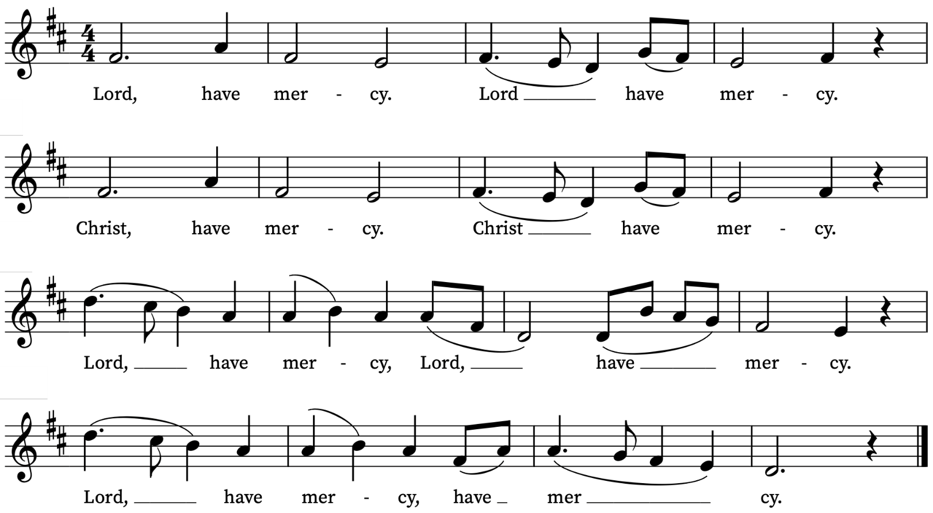
Old Testament Reading
Isaiah 2: 1-5
A reading from the Prophet Isaiah
The word that Isaiah son of Amoz saw concerning Judah and Jerusalem.
In days to come
the mountain of the Lord’s house
shall be established as the highest of the mountains,
and shall be raised above the hills;
all the nations shall stream to it.
Many peoples shall come and say,
‘Come, let us go up to the mountain of the Lord,
to the house of the God of Jacob;
that he may teach us his ways
and that we may walk in his paths.’
For out of Zion shall go forth instruction,
and the word of the Lord from Jerusalem.
He shall judge between the nations,
and shall arbitrate for many peoples;
they shall beat their swords into ploughshares,
and their spears into pruning-hooks;
nation shall not lift up sword against nation,
neither shall they learn war any more.
O house of Jacob,
come, let us walk
in the light of the Lord!
This is the Word of the Lord
Thanks be to God
Psalm 122
Laetatus sum
I was glad when they said unto me : We will go into the house of the Lord.
2 Our feet shall stand in thy gates : O Jerusalem.
3 Jerusalem is built as a city : that is at unity in itself.
4 For thither the tribes go up, even the tribes of the Lord : to testify unto Israel, to give thanks unto the Name of the Lord.
5 For there is the seat of judgement : even the seat of the house of David.
6 O pray for the peace of Jerusalem : they shall prosper that
love thee.
7 Peace be within thy walls : and plenteousness within thy palaces.
8 For my brethren and companions' sakes : I will wish thee prosperity.
9 Yea, because of the house of the Lord our God : I will seek to do thee good.
New Testament Reading
Romans 13: 11-14
A reading from the Letter of Paul to the Romans
Besides this, you know what time it is, how it is now the moment for you to wake from sleep. For salvation is nearer to us now than when we became believers; the night is far gone, the day is near. Let us then lay aside the works of darkness and put on the armour of light; let us live honourably as in the day, not in revelling and drunkenness, not in debauchery and licentiousness, not in quarrelling and jealousy. Instead, put on the Lord Jesus Christ, and make no provision for the flesh, to gratify its desires..
This is the Word of the Lord
Thanks be to God

Gospel
Matthew 24: 36-44
Hear the Gospel of our Lord Jesus Christ according to Matthew
Glory be to thee, O Lord
‘But about that day and hour no one knows, neither the angels of heaven, nor the Son, but only the Father. For as the days of Noah were, so will be the coming of the Son of Man. For as in those days before the flood they were eating and drinking, marrying and giving in marriage, until the day Noah entered the ark, and they knew nothing until the flood came and swept them all away, so too will be the coming of the Son of Man. Then two will be in the field; one will be taken and one will be left. Two women will be grinding meal together; one will be taken and one will be left. Keep awake therefore, for you do not know on what day your Lord is coming. But understand this: if the owner of the house had known in what part of the night the thief was coming, he would have stayed awake and would not have let his house be broken into. Therefore you also must be ready, for the Son of Man is coming at an unexpected hour.
This is the Gospel of the Lord
Praise be to thee, O Christ

Sanctus and Benedictus
Please join in singing the Sanctus and Benedictus from Schubert’s German Mass.
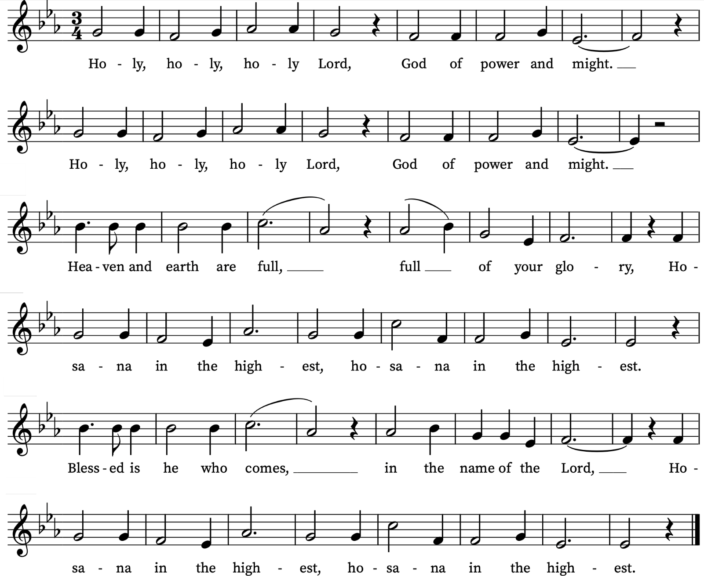

Agnus Dei
Please join in singing the Agnus Dei from Schubert’s German Mass.
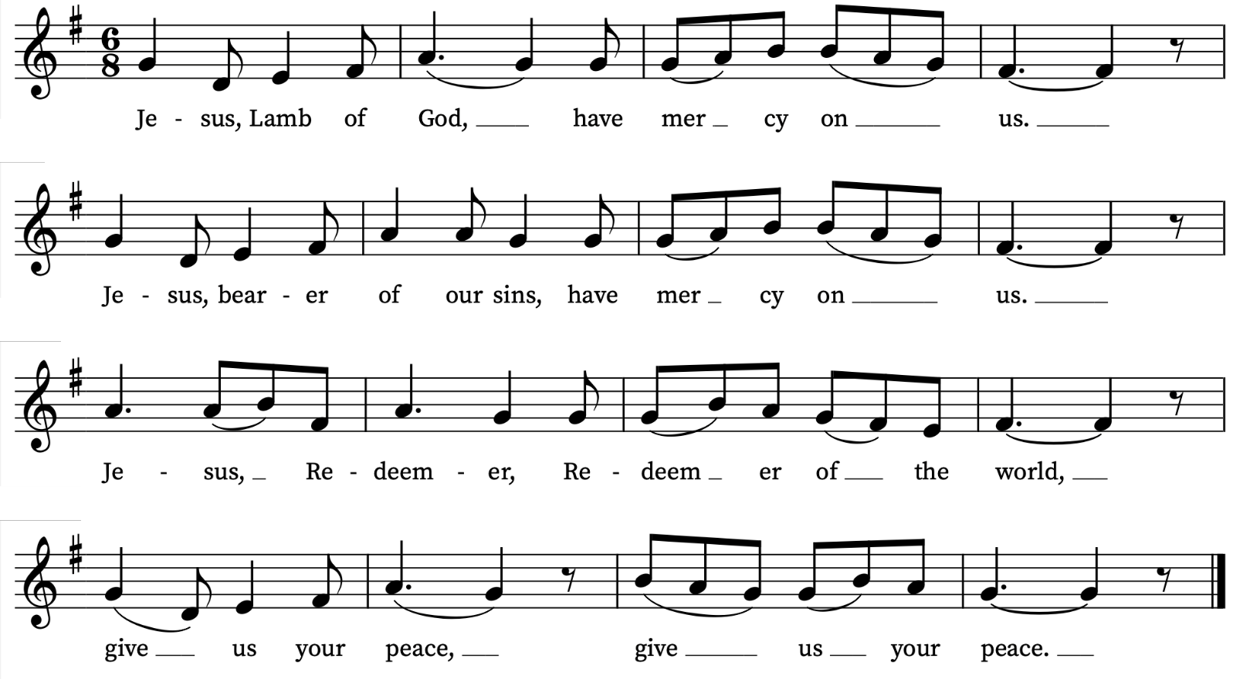

Today’s Music
Mass setting
Kyrie, Gloria, Sanctus/Benedictus and Agnus Dei from German Mass – Franz Schubert
Anthem
Es ist ein’ Ros’ entsprugen – Michael Praetorius
Es ist ein Ros entsprungen,  aus einer Wurzel zart,  wie uns die Alten sungen,  von Jesse kam die Art  und hat ein Blümlein bracht  mitten im kalten Winter,  wohl zu der halben Nacht.  Das Röslein, das ich meine,  davon Jesaias sagt,  hat uns gebracht alleine  Marie, die reine Magd.  Aus Gottes ew'gem Rat  hat sie ein Kind geboren  wohl zu der halben Nacht. | A Spotless Rose is blowing,  Sprung from a tender root,  Of ancient seers' foreshowing,  Of Jesse promised fruit;  Its fairest bud unfolds to light  Amid the cold, cold winter,  And in the dark midnight.  The Rose which I am singing,  Whereof Isaiah said,  Is from its sweet root springing  In Mary, purest Maid;  Through God's great love and might  The Blessed Babe she bare us  In a cold, cold winter's night.
Words: Anonymous (14th Century). Translation: Catherine Winkworth (1827-1878) Music: 14th Century German melody harmonized by Michael Praetorius (1571-1621)
Communion
A tender shoot – Otto Goldschmidt (1829-1907)
A tender shoot has started up from a root of grace,
as ancient seers imparted from Jesse's holy race:
It blooms without a blight,
blooms in the cold bleak winter,
turning our darkness into light.
This shoot, Isaiah taught us,
from Jesse's root should spring;
The Virgin Mary brought us the branch
of which we sing;
Our God of endless might gave her
this child to save us,
Thus turning darkness into light.
Original German text: Otto Goldschmidt,
English text: William Bartholomew (1793-1867)
Organ Postlude
Variations on a theme of Clément Jannequin – Jehan Alain

Prayers for the week
We pray for those in need: Aminta and Anthony, Fran Barlow, Ian Clark, Helen and Dan Delap, Andrew Fraser, Jo Fortheringham, Hessie and Nick Hervey, Glynne and Nancy John, Lena Kimming, James Markham, Lylian Meira, Nimal Menon, Tony Othen, Vinubhai Patel, Eva Preisich, Jessica Springbett, Jean Smith, Tina Stanley, Jessica Tipton, Sabrina Unold, George Voelker, Drew Webster, Pauline Youll, and Joshua Zitha.
We remember those who have died recently, including Gordon Anderson, Dan Iorga, Henny Rooijens, Catherine Varney and David Weaver. We ask God’s blessing and comfort on all mourning the loss of loved ones.
To include names of loved ones on the prayer list, please contact David McEvoy dmcevoy@btinternet.com
A prayer for the Holy Land
Gracious Father, whose blessed Son Jesus Christ came down from heaven to be the true bread which gives life to the world: In your mercy, provide for all those in Gaza and beyond who suffer from hunger and starvation, that they may be given both physical bread to nourish their bodies and heavenly bread to sustain their souls. By the power of your Spirit, bring a speedy end to this cruel war, the release of all captives, care for the sick and wounded, comfort for those who have lost loved-ones, and the opening of a pathway for a just and lasting peace here in the very homeland where your Son, our Lord Jesus Christ, ministered during his earthly life; who lives and reigns with you and the Holy Spirit, one God, now and forever. Amen.
The Most Reverend Dr Hosam E. Naoum, Anglican Archbishop in Jerusalem, August, 2025
Supporting St Alfege Church
Please do make a gift to support the life and ministry of St Alfege Church – during the collection in the service or by using a card reader at the North and West Doors. Please complete a Gift Aid envelope (if you are eligible) whether you donate by cash or card. You can also use this QR code to donate. | 
Advent & Christmas Services 2025
These special services for Advent and Christmas are in addition to our normal Sunday and weekday services
Sunday 30 November First Sunday of Advent
6.30pm Service of Music and Readings for Advent
A service of music and readings to begin the season, with St Alfege Church choir, directed by Joshua Ryan
Saturday 13 December
4pm Childrens Church | Christmas Window reveal with carols
Sunday 14 December Third Sunday of Advent
10am All Age Eucharist with Nativity Play
Parish Communion with Children’s Church Nativity Play
3pm Lugandan Christmas Service
Sunday 21 December Fourth Sunday of Advent
6.30pm Service of Nine Lessons and Carols
A candlelit service with readings, hymns and carols with St Alfege Church choir, directed by Joshua Ryan
Monday 22 December
6.30pm Blue Christmas service
A reflective service of Holy Communion close to the longest night, especially for those who find Christmas a difficult time.
Wednesday 24 December Christmas Eve
5.00pm Christingle and Crib Service
A short joyful candlelit service for all ages to begin Christmas.
11.00pm Midnight Mass
A choral celebration of Christmas with carols and candlelight
Thursday 25 December Christmas Day
11am Sung Eucharist
Holy Communion with carols for all ages on Christmas morning.
Sunday 28 December
8.00am Holy Communion (Said)(Book of Common Prayer)
10.00am Parish Eucharist (Sung)
Sunday 4 January 2026 Feast of Epiphany
8.00am Holy Communion (Said) (Book of Common Prayer) 10.00am Parish Eucharist (Sung)

Services this week
Today, Sunday 30 November Advent Sunday
8.00am Holy Communion (Book of Common Prayer)
10.00am Sung Eucharist
6.30pm Service of Music and Readings for Advent
Monday 1 December
8.30am Morning Prayer
Tuesday 2 December
8.30am Morning Prayer
Wednesday 3 December
8.30am Morning Prayer
Thursday 4 December
8.00am Holy Communion
Sunday 7 December Second Sunday of Advent
8.00am Holy Communion (Book of Common Prayer)
10.00am Sung Eucharist
No Abide service this month. Next service Sunday 4 January
at 5.30pm
Walk-In Wednesdays
Every Wednesday 10am-12noon in the Frank Smith Room in the hall.
Contact Us
Vicar: Revd Simon Winn
Curate: Revd Dr Tati Gutteridge
Church Office: 020 8853 0687
email: office@st-alfege.org.uk www.st-alfege.org.uk
Safeguarding Team
Karen Hansen Lead Safeguarding Officer 07866 932 894
Carole Moses Safeguarding Officer 07889 396 671
Irene Bishop Safeguarding Officer 020 8698 2658
safeguarding@st-alfege.org.uk

