
Parish Eucharist
with Nativity Play

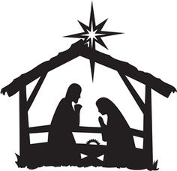

Third Sunday of Advent
14 December 2025 10am

Welcome to our service today, our Parish Eucharist with the Nativity Play presented by Children’s Church. This year the play is called ‘Put your trust in Jesus’.
The collection (during the Offertory Hymn), together with the collections from all our special services in Advent and Christmas will be divided equally between three charities:
- Embrace the Middle East
- St Alfege School food bank
- Greenwich Homeless Project
Please place your cash offering in the bags during the collection or use the contactless card reader (beside the south door) for electronic payments at the end of the service.
Please also note that if you are a UK tax payer the charity can claim 25% Gift Aid in addition to your donation. If you are eligible, please do complete a Gift Aid envelope and put your donation in it. If you are using the contactless card reader you can still complete a Gift Aid envelope but please write ‘contactless’ on the envelope together with a note of the amount you donated.
Our service is led by Revd Stephen Nshimye with St Alfege Church Choir directed Joshua Ryan. Ben Banks is the organist.
The Mass setting is Franz Schubert’s German Mass.
Please join in the hymns and prayers in bold type
The Christmas Tree has been donated in memory of Kevin Howes

The Gathering
Please stand

Opening Hymn
Hark the glad sound! the Saviour comes,
the Saviour promised long:
let every heart prepare a throne,
and every voice a song.
He comes, the prisoners to release
in Satan's bondage held;
the gates of brass before him burst,
the iron fetters yield.
He comes, the broken heart to bind,
the bleeding soul to cure,
and with the treasures of his grace
to enrich the humble poor.
Our glad hosannas, Prince of Peace,
thy welcome shall proclaim;
and heaven's eternal arches ring
with thy belovèd name.
Words: Philip Doddridge (1702-1751). Music: Thomas Ravenscroft (c.1582-1633)

Revd Stephen says
In the name of the Father,
and of the Son,
and of the Holy Spirit.
Amen
The Lord be with you
and also with you.
Words of Welcome

Lighting of the Third Advent Candle
Lord Jesus, light of the world,
John told the people to prepare,
for you were very near.
As Christmas grows closer day by day,
help us to be ready to welcome you now.
Amen.
Invitation to Confession
When the Lord comes,
he will bring to light the things now hidden in darkness,
and will disclose the purposes of the heart.
Therefore in the light of Christ let us confess our sins.
We keep silence and then sing

Kyrie
Please join in singing the Kyrie from Schubert’s German Mass.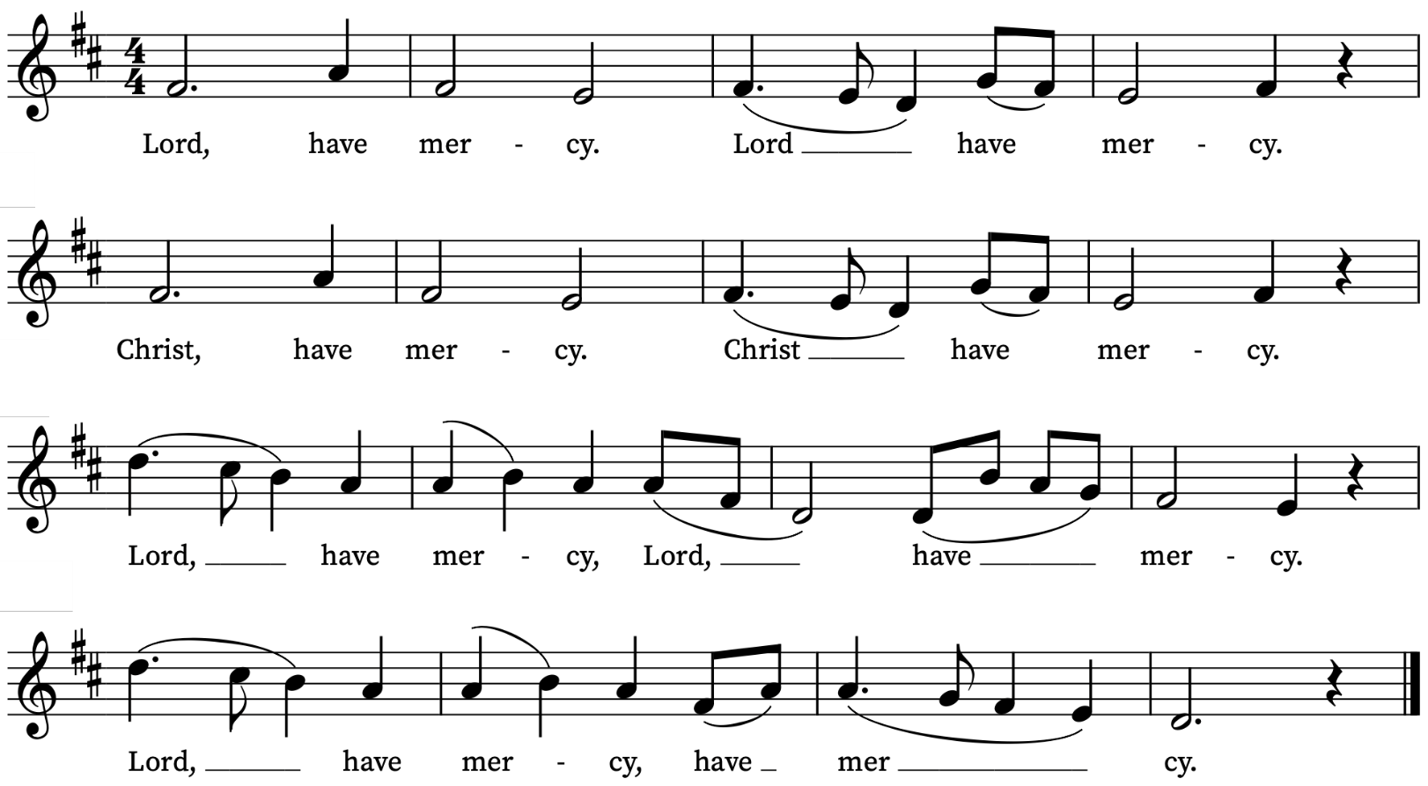

Absolution
May the God of all healing and forgiveness
draw you to himself, and cleanse you from all your sins
that you may behold the glory of his Son,
the Word made flesh, Jesus Christ our Lord.
Amen

Collect
God for whom we watch and wait,
you sent John the Baptist to prepare the way of your Son:
give us courage to speak the truth,
to hunger for justice,
and to suffer for the cause of right,
with Jesus Christ our Lord. Amen
Please sit
The Liturgy of the Word
Old Testament Reading
Read by Janelle Hanford-Spira
Isaiah 35: 1-10
A reading from the prophet Isaiah
The wilderness and the dry land shall be glad,
the desert shall rejoice and blossom;
like the crocus it shall blossom abundantly,
and rejoice with joy and singing.
The glory of Lebanon shall be given to it,
the majesty of Carmel and Sharon.
They shall see the glory of the Lord,
the majesty of our God.
Strengthen the weak hands,
and make firm the feeble knees.
Say to those who are of a fearful heart,
‘Be strong, do not fear!
Here is your God.
He will come with vengeance,
with terrible recompense.
He will come and save you.’
Then the eyes of the blind shall be opened,
and the ears of the deaf unstopped;
then the lame shall leap like a deer,
and the tongue of the speechless sing for joy.
For waters shall break forth in the wilderness,
and streams in the desert;
the burning sand shall become a pool,
and the thirsty ground springs of water;
the haunt of jackals shall become a swamp,
the grass shall become reeds and rushes.
A highway shall be there,
and it shall be called the Holy Way;
the unclean shall not travel on it,
but it shall be for God’s people;
no traveller, not even fools, shall go astray.
No lion shall be there,
nor shall any ravenous beast come up on it;
they shall not be found there,
but the redeemed shall walk there.
And the ransomed of the Lord shall return,
and come to Zion with singing;
everlasting joy shall be upon their heads;
they shall obtain joy and gladness,
and sorrow and sighing shall flee away.
This is the Word of the Lord
Thanks be to God

Nativity Play
performed by Children’s Church:
‘Put your trust in Jesus’
Created and produced by Alison Wood, Moira Searle, and Robbie Swales.
Please do join in singing verses from these carols included in the play:
Little Donkey
Little donkey, little donkey
On the dusty road
Got to keep on plodding onwards
With your precious load.
Been a long time, little donkey
Through the winter's night
Don't give up now, little donkey
Bethlehem's in sight.
Ring out those bells tonight
Bethlehem, Bethlehem
Follow that star tonight
Bethlehem, Bethlehem.
Little donkey, little donkey
Had a heavy day,
Little donkey,
Carry Mary safely on her way.

While Shepherds Watched
To you, in David's town, this day
is born of David's line
a Saviour, who is Christ the Lord;
and this shall be the sign:
The heavenly babe you there shall find
to human view displayed,
all meanly wrapped in swathing bands
and in a manger laid.
All glory be to God on high,
and to the earth be peace;
Goodwill henceforth from highest heaven
Begin and never cease!
We Three Kings
We three kings of Orient are;
bearing gifts we traverse afar,
field and fountain, moor and mountain,
following yonder star.
O star of wonder, star of light,
star with royal beauty bright,
westward leading, still proceeding,
guide us to thy perfect light.
Joy to the World
Joy to the world! the Lord is come;
Let earth receive her King;
Let every heart prepare him room,
And heaven and nature sing,
And heaven and nature sing,
And heaven, and heaven, and nature sing.

Joy to the world! the Saviour reigns;
Let men their songs employ;
While fields and floods, rocks, hills, and plains
Repeat the sounding joy,
Repeat the sounding joy,
Repeat, repeat the sounding joy.
He rules the world with truth and grace,
And makes the nations prove
The glories of His righteousness,
And wonders of His love,
And wonders of His love,
And wonders, wonders, of His love.

Choir Anthem
The Choir sings Dormi Jesu by John Rutter
Sleep, sweet babe!
my cares beguiling: mother sits beside thee smiling;
Sleep, my darling, tenderly!
If thou sleep not, mother mourneth,
singing as her wheel she turneth:
Come, soft slumber, balmily!

Prayers of Intercession

led by Arno Levin

Bidding: Lord Jesus,
Response: hear our prayer.

The Liturgy of the Sacrament

The Peace

Please stand. Revd Stephen says
In the tender mercy of our God,
the dayspring from on high shall break upon us,
to give light to those who dwell in darkness
and in the shadow of death,
and to guide our feet into the way of peace.
The peace of the Lord be always with you
and also with you.
Let us offer one another a sign of peace.
The collection will be taken during the Offertory Hymn for the three charities we are supporting in Advent and Christmas (please see page 2). Please place your cash offering in the bags during the collection or use the contactless card reader (at the West and North doors) at the end of the service.

Offertory Hymn
See him lying on a bed of straw,
a draughty stable with an open door;
Mary cradling the babe she bore —
the Prince of glory is his name.
Refrain:
O now carry me to Bethlehem
to see the Lord of love again:
just as poor as was the stable then,
the Prince of glory when he came!
Star of silver, sweep across the skies,
show where Jesus in the manger lies;
shepherds, swiftly from your stupor rise
to see the Saviour of the world! [Refrain]
Angels, sing again the song you sang,
sing the glory of God's gracious plan;
sing that Bethl'em's little baby can
be salvation to the soul. [Refrain]
Mine are riches, from your poverty;
from your innocence, eternity;
mine, forgiveness by your death for me,
child of sorrow for my joy.
Refrain:
O now carry me to Bethlehem
to see the Lord of love again:
just as poor as was the stable then,
the Prince of glory when he came!
Words and music: Michael Perry (1942-1996)

Prayer at the Preparation of the Table
Look upon us in mercy not in judgement;
draw us from hatred to love;
make the frailty of our praise
a dwelling place for your glory.
Amen.

Eucharistic Prayer
The Lord be with you
and also with you.
Lift up your hearts.
We lift them to the Lord.
Let us give thanks to the Lord our God.
It is right to give thanks and praise

Father, you made the world and love your creation.
You gave your Son Jesus Christ to be our Saviour.
His dying and rising have set us free from sin and death.
And so we gladly thank you,
with saints and angels praising you, and singing:

Sanctus and Benedictus
Please join in singing the Sanctus and Benedictus from Schubert’s German Mass

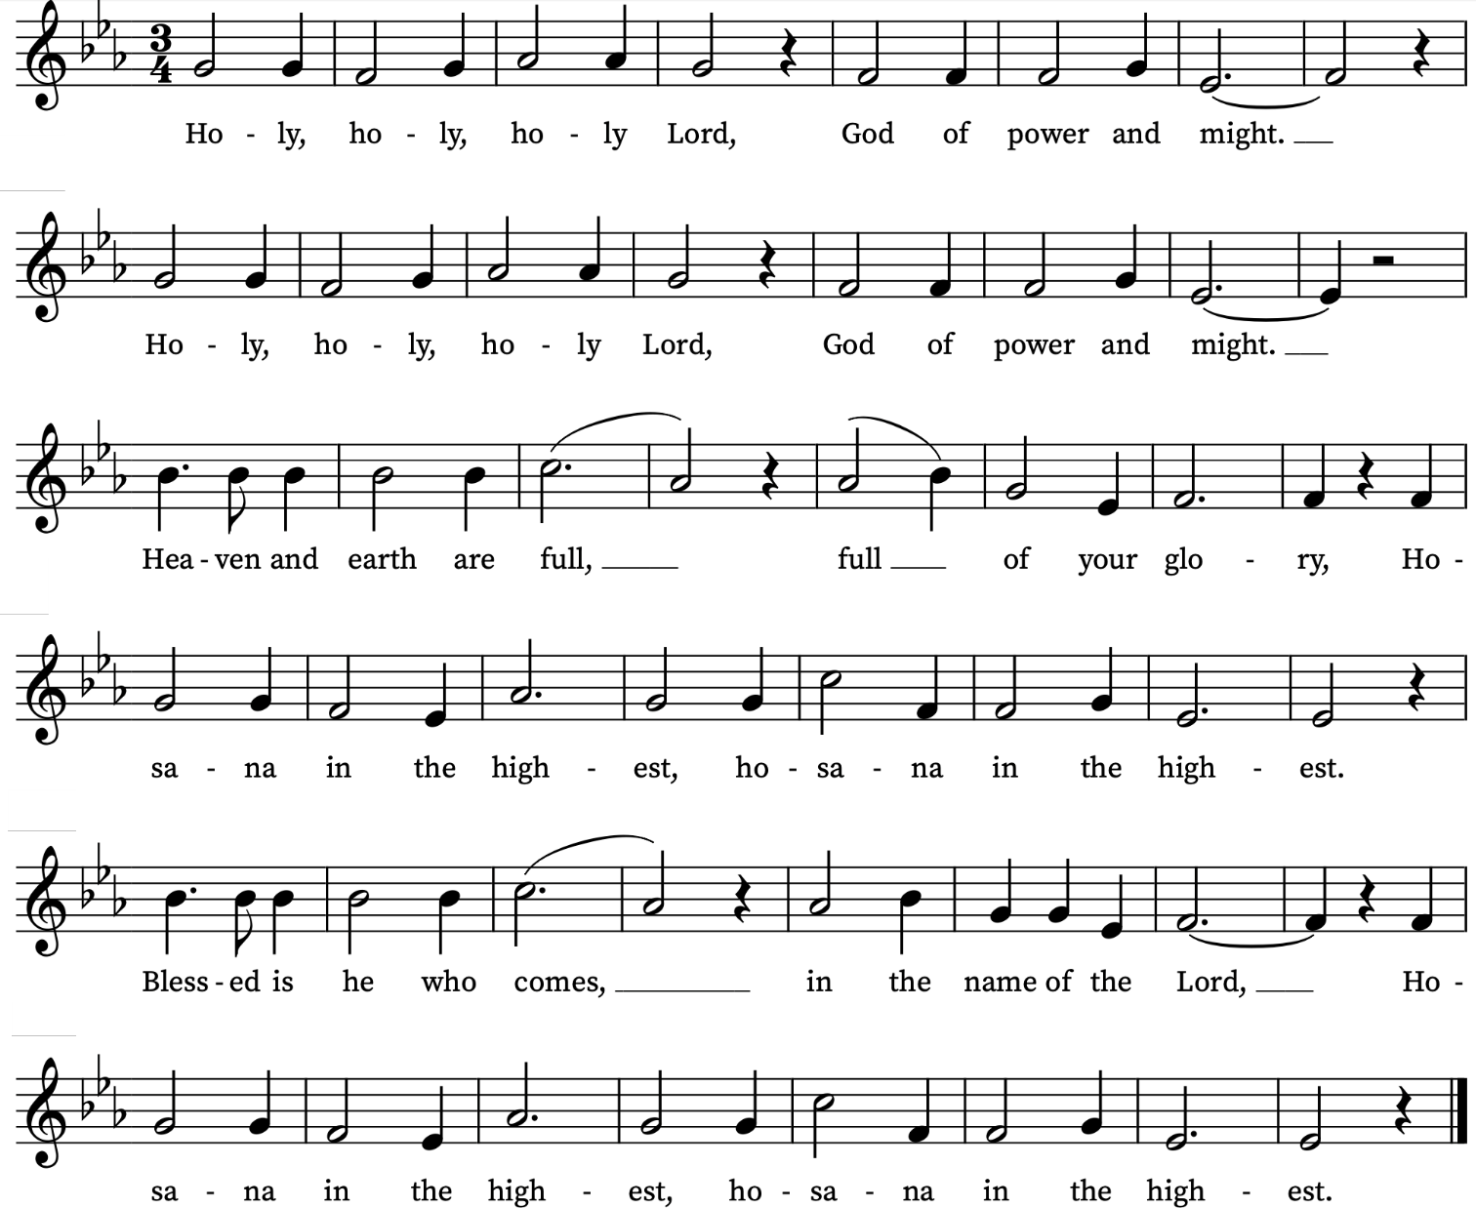

Please sit
We praise and bless you, loving Father,
through Jesus Christ, our Lord;
and as we obey his command,
send your Holy Spirit,
that broken bread and wine outpoured
may be for us the body and blood of your dear Son.
On the night before he died he had supper with his friends
and, taking bread, he praised you.
He broke the bread, gave it to them and said:
Take, eat; this is my body which is given for you;
do this in remembrance of me.
When supper was ended he took the cup of wine.
Again he praised you, gave it to them and said:
Drink this, all of you;
this is my blood of the new covenant,
which is shed for you and for many for the forgiveness of sins.
Do this, as often as you drink it, in remembrance of me.
So, Father, we remember all that Jesus did,
in him we plead with confidence his sacrifice
made once for all upon the cross.
Bringing before you the bread of life and cup of salvation,
we proclaim his death and resurrection
until he comes in glory
Great is the mystery of faith:
Christ has died:
Christ is risen:
Christ will come again.
Lord of all life,
help us to work together for that day
when your kingdom comes
and justice and mercy will be seen in all the earth.
Look with favour on your people,
gather us in your loving arms
and bring us to feast at your table in heaven.
Through Christ, and with Christ, and in Christ,
in the unity of the Holy Spirit,
all honour and glory are yours, O loving Father,
for ever and ever. Amen.

The Lord's Prayer
As we look for the coming of God’s kingdom,
Lord teach us to pray:
Our Father, who art in heaven,
hallowed be thy name;
thy kingdom come; thy will be done;
on earth as it is in heaven.
Give us this day our daily bread.
And forgive us our trespasses
as we forgive those who trespass against us.
And lead us not into temptation;
but deliver us from evil.
For thine is the kingdom,
the power and the glory,
for ever and ever. Amen

Breaking of the Bread
We break this bread
to share in the body of Christ.
Though we are many, we are one body,
because we all share in one bread.

Agnus Dei
Please join in singing the Agnus Dei from Schubert’s German Mass.
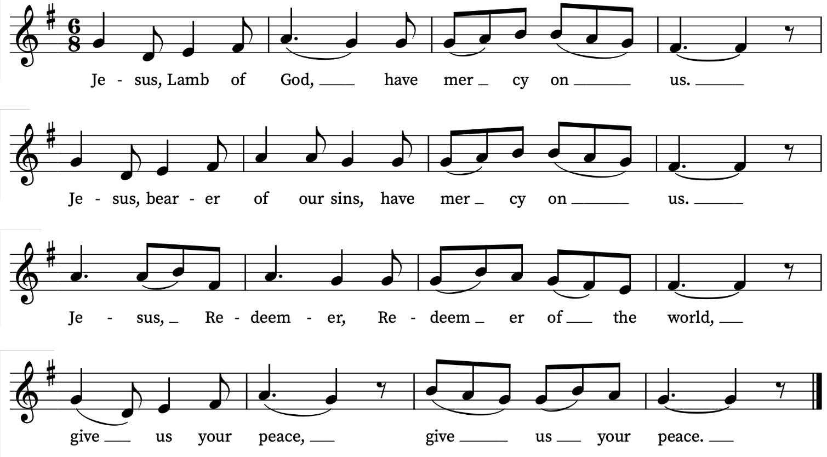

Giving of Communion
God's holy gifts for God's holy people.
Jesus Christ is holy, Jesus Christ is Lord,
to the glory of God the Father.
Everyone who is a baptised member of a Christian church is invited to receive the sacrament, after which we reply Amen.
Please come forward as directed by a welcomer. If you need communion brought to you please let a welcomer know.
If you would like to receive a blessing rather than communion, please bow your head.
Please let a welcomer know if you need a gluten-free wafer.
We offer communion in both kinds, the bread (wafer) and the wine (in the cup or chalice). If you would prefer not to receive the wine from the chalice/cup please bow your head or simply leave the altar rail after receiving the wafer. Please do not intinct (dip your wafer in the chalice).
Please return to your seats via the side chapels.
Communion Motets
During Communion the choir will sing
This is the record of John – Orlando Gibbons
This is the record of John,
when the Jews sent priests and Levites from Jerusalem to ask him, Who art thou?
And he confessed, and denied not,
and said plainly, I am not the Christ.
And they asked him, What art thou then? Art thou Elias?
And he said, I am not.
Art thou that Prophet? And he answered, No.
Then said they unto him, What art thou? that we may give an answer unto them that sent us.
What say’st thou of thyself?
And he said,
I am the voice of him that crieth in the wilderness,
Make straight the way of the Lord.
Words: John 1: 19–23

Prayer after Communion
Almighty God, we thank you for feeding us
with the body and blood of your Son Jesus Christ.
Through him we offer you our souls and bodies
to be a living sacrifice. Send us out in the power of your Spirit to live and work to your praise and glory. Amen.
Notices
Please stand for the final hymn
Hymn
Come, thou long expected Jesus,
born to set thy people free;
from our fears and sins release us,
let us find our rest in thee.
Israel's strength and consolation,
hope of all the earth thou art;
dear desire of every nation,
joy of every longing heart.
Born thy people to deliver,
born a child and yet a King,
born to reign in us forever,
now thy gracious kingdom bring.
By thine own eternal spirit
rule in all our hearts alone;
by thine all sufficient merit,
raise us to thy glorious throne.
Charles Wesley (1707-1788)
The Blessing and Dismissal
Christ the Sun of Righteousness shine upon you, scatter the darkness from before your path, and make you ready to meet him when he comes in glory; and the blessing of God almighty, the Father, the Son and the Holy Spirit, be among you and remain with you always. Amen.

As we await our coming Saviour,
go in peace to love and serve the Lord.
In the name of Christ. Amen.
We remain standing as the choir, servers and clergy
process out.
Organ voluntary
Jingle Bell Rock – Beal & Booth, arr. Banks

Please come and enjoy refreshments in the church hall after the service

From Common Worship Order One, Traditional Language Copyright © The Archbishops Council 2000.

Prayers for the week
We pray for those in need: Aminta and Anthony, Fran Barlow, Ian Clark, Helen and Dan Delap, Andrew Fraser, Jo Fortheringham, Hessie and Nick Hervey, Glynne and Nancy John, Lena Kimming, James Markham, Lylian Meira, Nimal Menon, Nicola Orme, Tony Othen, Vinubhai Patel, Eva Preisich, Jessica Springbett, Jean Smith, Tina Stanley, Jessica Tipton, Sabrina Unold, George Voelker, Drew Webster, Pauline Youll, and Joshua Zitha.
We remember those who have died recently, including Gordon Anderson, Dan Iorga, Catherine Varney and David Weaver. We also remember Krassimir Georgiev, Jean Sharp and Bobby Kinnison on their year’s mind. We ask God’s blessing and comfort on all mourning the loss of loved ones.
To include names of loved ones on the prayer list, please contact David McEvoy dmcevoy@btinternet.com
Find Out More
You can find details of our regular services and our Church on our website: www.st-alfege.org.uk
Vicar: Revd Simon Winn
Curate: Revd Dr Tati Gutteridge
Church Office: office@st-alfege.org.uk
020 8853 0687 www.st-alfege.org.uk
Supporting St Alfege Church
We would also ask you to consider setting up a regular standing order to St Alfege Church to support the work and ministry of the church. Account: PCC of St Alfege, Greenwich. Sort Code: 60-09-16 Account number: 25249304. You can also use this QR code to donate. | 

Services this week
Today, Sunday 14 December Third Sunday of Advent
8.00am Holy Communion (Book of Common Prayer)
10.00am Parish Eucharist with Nativity Play
12.45 to 2.00pm (approx.) Short reflection in church followed by a performance of a cohort of Pipes and Drums from General Gordon School outside the church (General Gordon was baptized here)
3pm Okutendereza mu Luganda Christmas celebration service
Monday 15 December
8.30am Morning Prayer
Tuesday 16 December
8.30am Morning Prayer
Wednesday 17 December
8.30am Morning Prayer
Thursday 18 December
8.00am Holy Communion
Sunday 21 December Fourth Sunday of Advent
8.00am Holy Communion (Book of Common Prayer)
10.00am Sung Eucharist
6.30pm Service of Nine Lessons and Carols
A candlelit service with readings, hymns and carols
Walk-In Wednesdays
Every Wednesday 10am-12noon in the Frank Smith Room in the hall.
Contact Us
Vicar: Revd Simon Winn
Curate: Revd Dr Tati Gutteridge
Church Office: 020 8853 0687
email: office@st-alfege.org.uk
website: www.st-alfege.org.uk
Safeguarding Team
safeguarding@st-alfege.org.uk
Advent & Christmas Services 2025
These special services for Advent and Christmas are in addition to our normal Sunday and weekday services
Sunday 21 December Fourth Sunday of Advent
6.30pm Service of Nine Lessons and Carols
A candlelit service with readings, hymns and carols with St Alfege Church choir, directed by Joshua Ryan
Monday 22 December
6.30pm Blue Christmas service
A reflective service of Holy Communion close to the longest night, especially for those who find Christmas a difficult time.
Wednesday 24 December Christmas Eve
5.00pm Christingle and Crib Service
A short joyful candlelit service for all ages to begin Christmas.
11.00pm Midnight Mass
A choral celebration of Christmas with carols and candlelight
Thursday 25 December Christmas Day
11am Sung Eucharist
Holy Communion with carols for all ages on Christmas morning.
Sunday 28 December
8.00am Holy Communion (Said)(Book of Common Prayer)
10.00am Parish Eucharist (Sung)
Sunday 4 January 2026 Feast of Epiphany
8.00am Holy Communion (Said) (Book of Common Prayer) 10.00am Parish Eucharist (Sung)

Please take this booklet home with you

