

Parish Eucharist
Feast of the Epiphany
4 January 2026
Welcome to our services of Holy Communion today. Revd Simon Winn, Vicar, is presiding and preaching at 8am and 10am. The Choir and Children’s Church return from their break today. We sing together the Kyrie from Schubert’s German Mass (on pages 6 to 10 of this sheet).
Readings
Isaiah 60: 1-6
Psalm 72
Ephesians 3: 1-12
Matthew 2: 1-12
Hymns
462 ‘Glory to God!’ all heav’n with joy is ringing
48 Earth has many a noble city
51 As with gladness men of old
47 Brightest and Best of the sons of the morning (Tune Epiphany)
Collect
O God, who by the leading of a star manifested your only Son to the peoples of the earth: mercifully grant that we, who know you now by faith, may at last behold your glory face to face;
through Jesus Christ your Son our Lord, who is alive and reigns with you, in the unity of the Holy Spirit, one God, now and for ever. Amen
Prayer after Communion
Lord God, the bright splendour whom the nations seek: may we who with the wise men have been drawn by your light discern the glory of your presence in your Son, the Word made flesh, Jesus Christ our Lord. Amen

Kyrie
We sing the Kyrie from Schubert’s German Mass
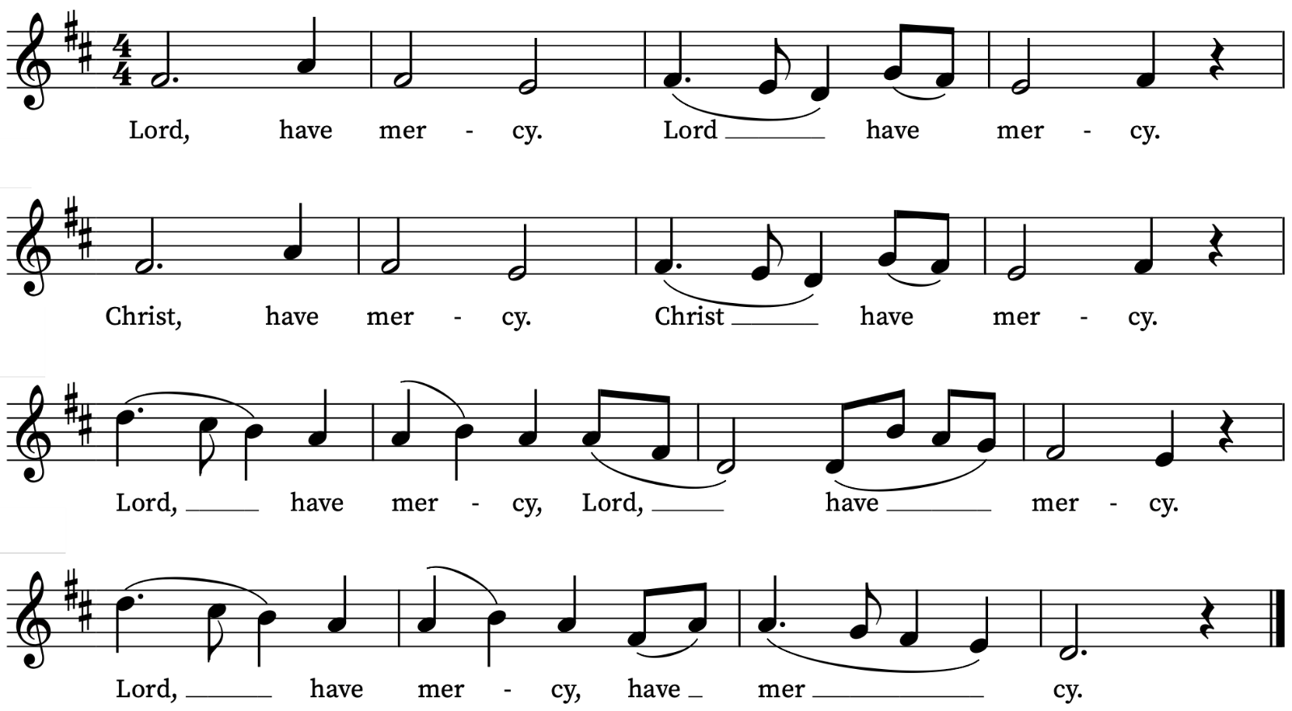
Old Testament Reading
Isaiah 60: 1-6
A reading from the Prophet Isaiah
Arise, shine; for your light has come,
and the glory of the Lord has risen upon you.
For darkness shall cover the earth,
and thick darkness the peoples;
but the Lord will arise upon you,
and his glory will appear over you.
Nations shall come to your light,
and kings to the brightness of your dawn.
Lift up your eyes and look around;
they all gather together, they come to you;
your sons shall come from far away,
and your daughters shall be carried on their nurses’ arms.
Then you shall see and be radiant;
your heart shall thrill and rejoice,
because the abundance of the sea shall be brought to you,
the wealth of the nations shall come to you.
A multitude of camels shall cover you,
the young camels of Midian and Ephah;
all those from Sheba shall come.
They shall bring gold and frankincense,
and shall proclaim the praise of the Lord.
This is the Word of the Lord
Thanks be to God
Psalm 72: 10-15
Deus, judicium
10 The kings of Tharsis and of the isles shall give presents : the kings of Arabia and Saba shall bring gifts.
11 All kings shall fall down before him : all nations shall do him service.
12 For he shall deliver the poor when he crieth : the needy also, and him that hath no helper.
13 He shall be favourable to the simple and needy : and shall preserve the souls of the poor.
14 He shall deliver their souls from falsehood and wrong : and dear shall their blood be in his sight.
15 He shall live, and unto him shall be given of the gold of Arabia : prayer shall be made ever unto him, and daily shall he be praised.

New Testament Reading
Ephesians 3: 1-12
A reading from Paul’s Letter to the Ephesians
This is the reason that I Paul am a prisoner for Christ Jesus for the sake of you Gentiles— for surely you have already heard of the commission of God’s grace that was given to me for you, and how the mystery was made known to me by revelation, as I wrote above in a few words, a reading of which will enable you to perceive my understanding of the mystery of Christ. In former generations this mystery was not made known to humankind, as it has now been revealed to his holy apostles and prophets by the Spirit: that is, the Gentiles have become fellow-heirs, members of the same body, and sharers in the promise in Christ Jesus through the gospel.
Of this gospel I have become a servant according to the gift of God’s grace that was given to me by the working of his power. Although I am the very least of all the saints, this grace was given to me to bring to the Gentiles the news of the boundless riches of Christ, and to make everyone see what is the plan of the mystery hidden for ages in God who created all things; so that through the church the wisdom of God in its rich variety might now be made known to the rulers and authorities in the heavenly places. This was in accordance with the eternal purpose that he has carried out in Christ Jesus our Lord, in whom we have access to God in boldness and confidence through faith in him.
This is the Word of the Lord
Thanks be to God
Gospel Reading
Matthew 2: 1-12
Hear the Gospel of our Lord Jesus Christ according to Matthew
Glory be to thee, O Lord
In the time of King Herod, after Jesus was born in Bethlehem of Judea, wise men from the East came to Jerusalem, asking, ‘Where is the child who has been born king of the Jews? For we observed his star at its rising, and have come to pay him homage.’ When King Herod heard this, he was frightened, and all Jerusalem with him; and calling together all the chief priests and scribes of the people, he inquired of them where the Messiah was to be born. They told him, ‘In Bethlehem of Judea; for so it has been written by the prophet:
“And you, Bethlehem, in the land of Judah,
are by no means least among the rulers of Judah;
for from you shall come a ruler
who is to shepherd my people Israel.”’
Then Herod secretly called for the wise men and learned from them the exact time when the star had appeared. Then he sent them to Bethlehem, saying, ‘Go and search diligently for the child; and when you have found him, bring me word so that I may also go and pay him homage.’ When they had heard the king, they set out; and there, ahead of them, went the star that they had seen at its rising, until it stopped over the place where the child was. When they saw that the star had stopped, they were overwhelmed with joy. On entering the house, they saw the child with Mary his mother; and they knelt down and paid him homage. Then, opening their treasure-chests, they offered him gifts of gold, frankincense, and myrrh. And having been warned in a dream not to return to Herod, they left for their own country by another road.
This is the Gospel of the Lord
Praise be to thee, O Christ
Today’s Music
Mass setting
Communion Service in E – Harold Darke
Anthem
The Three Kings – Peter Cornelius

Three Kings from Persian lands afar

To Jordan follow the pointing star:

And this the quest of the travellers three,

Where the new-born King of the Jews may be.

Full royal gifts they bear for the King;

Gold, incense, myrrh are their offering.

How brightly shines the morning star!

With grace and truth from heaven afar

Our Jesse tree now bloweth.

The star shines out with a steadfast ray;

The kings to Bethlehem make their way,

And there in worship they bend the knee,

As Mary’s child in her lap they see;

Their royal gifts they show to the King;

Gold, incense, myrrh are their offering.

Of Jacob’s stem and David’s line,

For Thee, my Bridegroom, King divine,

My soul with love o’erfloweth.

Thou child of man, lo, to Bethlehem

The Kings are travelling, travel with them!

The star of mercy, the star of grace,

Shall lead thy heart to its resting place.

Gold, incense, myrrh thou canst not bring;

Offer thy heart to the infant King.

Thy word, Jesu, Inly feeds us,

Rightly leads us, Life bestowing.

Praise, O praise such love o’erflowing.
Communion
Agnus Dei from Communion Service in E – Harold Darke
Bethlehem Down – Peter Warlock
“When He is King we will give him the King’s gifts,
Myrrh for its sweetness, and gold for a crown,
Beautiful robes”, said the young girl to Joseph
Fair with her first-born on Bethlehem Down.
Bethlehem Down is full of the starlight
Winds for the spices, and stars for the gold,
Mary for sleep, and for lullaby music
Songs of a shepherd by Bethlehem fold.
When He is King they will clothe Him in grave-sheets,
Myrrh for embalming, and wood for a crown,
He that lies now in the white arms of Mary
Sleeping so lightly on Bethlehem Down.
Here He has peace and a short while for dreaming,
Close-huddled oxen to keep Him from cold,
Mary for love, and for lullaby music
Songs of a shepherd by Bethlehem fold.
Words by Bruce Blunt
Organ Postlude
In dir ist Freude BWV 615 – J.S. Bach
Abide
Today Sunday 4 January at 5.30pm
A contemplative service with meditation, prayer, reflections from the English mystic Julian of Norwich and music from the Taizé tradition.
Prayers for the week
We pray for those in need: Anthony, Fran Barlow, Ian Clark, Helen and Dan Delap, Delroy Donegal, Andrew Fraser, Jo Fortheringham, Hessie and Nick Hervey, Carole Hubble, Glynne and Nancy John, Lena Kimming, James Markham, Lylian Meira, Nancy Mence, Nimal Menon, Jim Odell,Nicola Orme, Tony Othen, Vinubhai Patel, Eva Preisich, Jessica Springbett, Jean Smith, Tina Stanley, Jessica Tipton, Sabrina Unold, George Voelker, Drew Webster, Pauline Youll, and Joshua Zitha.
We remember those who have died recently, including Gordon Anderson, Ted Cantrell, Faith Clarke, Ken Eastwood, Christopher Follett, Margaret Foreman, Glynne John, Aminta Prowse, Ian McWilliam, and David Weaver. We ask God’s blessing and comfort on all mourning the loss of loved ones.
To include names of loved ones on the prayer list, please contact David McEvoy dmcevoy@btinternet.com

Services this Week
Sunday 4 January 2026 Feast of the Epiphany
8.00am Holy Communion (Book of Common Prayer)
10.00am Parish Eucharist
5.30pm Abide, a meditative service with music from Taizé
Monday 5 January
8.30am Morning Prayer
Tuesday 6 January
8.30am Morning Prayer
Wednesday 7 January
8.30am Morning Prayer
Thursday 8 January
8.00am Holy Communion
Sunday 11 January 2026 Baptism of Christ
8.00am Holy Communion (Said) (Book of Common Prayer)
10.00am Choral Eucharist and Children’s Church
Walk-In Wednesdays
Every Wednesday 10am-12noon in the Small Hall.
Supporting St Alfege Church
Please do make a gift to support the life and ministry of St Alfege Church – during the collection in the service or by using a card reader at the North and West Doors. Please complete a Gift Aid envelope (if you are eligible) whether you donate by cash or card. You can also use this QR code to donate. | 
Contact Us
Vicar: Revd Simon Winn
Curate: Revd Dr Tati Gutteridge (on maternity leave)
Church Office: 020 8853 0687
email: office@st-alfege.org.uk www.st-alfege.org.uk
Safeguarding Team
safeguarding@st-alfege.org.uk

