

Sung Eucharist
Baptism of Christ
Sunday 11 January 2026
Welcome to our services of Holy Communion today. Revd Simon Winn, Vicar, is presiding at 8am and Revd Stephen Nshimye at 10am. David McEvoy, Reader, is preaching at both services. Revd Simon is leading worship at St Mary’s Woolwich at 10am. We sing together the Kyrie from Schubert’s German Mass (on page 3 of this sheet).
Readings
Isaiah 42: 1-9
Psalm 29
Acts 10: 34-43
Matthew 3: 13-17
Hymns
49 O worship the Lord in the beauty of holiness
When Jesus comes to be baptized (on page 5 of this sheet)
142 Hail to the Lord’s Anointed
53 Songs of thankfulness and praise ( omit verse 4)
Collect
Eternal Father, who at the baptism of Jesus revealed him to be your Son, anointing him with the Holy Spirit: grant to us, who are born again by water and the Spirit, that we may be faithful to our calling as your adopted children; through Jesus Christ your Son our Lord, who is alive and reigns with you, in the unity of the Holy Spirit, one God, now and for ever. Amen
Prayer after Communion
Lord of all time and eternity, you opened the heavens and revealed yourself as Father in the baptism of Jesus your beloved Son: by the power of your Spirit complete the heavenly work of our rebirth through the waters of the new creation; through Jesus Christ our Lord. Amen

Kyrie
We sing the Kyrie from Schubert’s German Mass
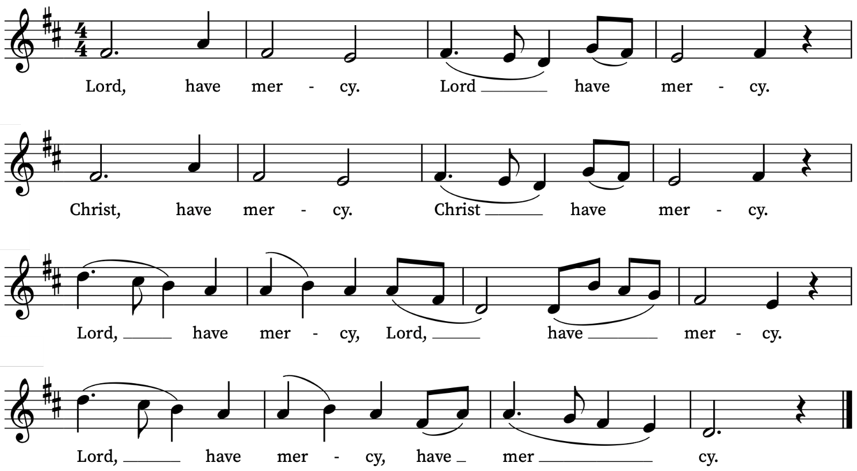
Old Testament Reading
Isaiah 42: 1-9
A reading from the Prophet Isaiah
Here is my servant, whom I uphold,
my chosen, in whom my soul delights;
I have put my spirit upon him;
he will bring forth justice to the nations.
He will not cry or lift up his voice,
or make it heard in the street;
a bruised reed he will not break,
and a dimly burning wick he will not quench;
he will faithfully bring forth justice.
He will not grow faint or be crushed
until he has established justice in the earth;
and the coastlands wait for his teaching.
Thus says God, the Lord,
who created the heavens and stretched them out,
who spread out the earth and what comes from it,
who gives breath to the people upon it
and spirit to those who walk in it:
I am the Lord, I have called you in righteousness,
I have taken you by the hand and kept you;
I have given you as a covenant to the people,
a light to the nations,
to open the eyes that are blind,
to bring out the prisoners from the dungeon,
from the prison those who sit in darkness.
I am the Lord, that is my name;
my glory I give to no other,
nor my praise to idols.
See, the former things have come to pass,
and new things I now declare;
before they spring forth,
I tell you of them.
This is the Word of the Lord
Thanks be to God
Psalm 29
Afferte Domino
Bring unto the Lord, O ye mighty, bring young rams unto the Lord : ascribe unto the Lord worship and strength.
2 Give the Lord the honour due unto his Name : worship the Lord with holy worship.
3 It is the Lord that commandeth the waters : it is the glorious God that maketh the thunder.
4 It is the Lord that ruleth the sea; the voice of the Lord is mighty in operation : the voice of the Lord is a glorious voice.
5 The voice of the Lord breaketh the cedar-trees : yea, the Lord breaketh the cedars of Libanus.
6 He maketh them also to skip like a calf : Libanus also, and Sirion, like a young unicorn.
7 The voice of the Lord divideth the flames of fire; the voice of the Lord shaketh the wilderness: yea, the Lord shaketh the wilderness of Cades.
8 The voice of the Lord maketh the hinds to bring forth young, and discovereth the thick bushes : in his temple doth every man speak of his honour.
9 The Lord sitteth above the water-flood : and the Lord remaineth a King for ever.
10 The Lord shall give strength unto his people : the Lord shall give his people the blessing of peace.
New Testament Reading
Acts 10: 34-43
A reading from the book of Acts
Then Peter began to speak to them: ‘I truly understand that God shows no partiality, but in every nation anyone who fears him and does what is right is acceptable to him. You know the message he sent to the people of Israel, preaching peace by Jesus Christ—he is Lord of all. That message spread throughout Judea, beginning in Galilee after the baptism that John announced: how God anointed Jesus of Nazareth with the Holy Spirit and with power; how he went about doing good and healing all who were oppressed by the devil, for God was with him. We are witnesses to all that he did both in Judea and in Jerusalem. They put him to death by hanging him on a tree; but God raised him on the third day and allowed him to appear, not to all the people but to us who were chosen by God as witnesses, and who ate and drank with him after he rose from the dead. He commanded us to preach to the people and to testify that he is the one ordained by God as judge of the living and the dead. All the prophets testify about him that everyone who believes in him receives forgiveness of sins through his name.’
This is the Word of the Lord
Thanks be to God
Gradual Hymn
When Jesus comes to be baptized,
he leaves the hidden years behind,
the years of safety and of peace,
to bear the sins of humankind.
The Spirit of the Lord comes down,
anoints the Christ to suffering,
to preach the word, to free the bound,
and to the mourner comfort bring.
He will not quench the dying flame,
and what is bruised he will not break,
but heal the wound injustice dealt,
and out of death his triumph make.
Our everlasting Father praise
with Christ, his well beloved Son,
who with the Spirit reigns serene,
eternal Trinity in One.
Words: The Benedictine Community of Stanbrook Abbey. Melody: Herongate
Gospel Reading
Matthew 3: 13-17
Alleluia, alleluia.
Christ was revealed in the flesh, proclaimed among the nations
And believed in throughout the world.
Alleluia
Hear the Gospel of our Lord Jesus Christ according to Matthew
Glory be to thee, O Lord
Then Jesus came from Galilee to John at the Jordan, to be baptized by him. John would have prevented him, saying, ‘I need to be baptized by you, and do you come to me?’ But Jesus answered him, ‘Let it be so now; for it is proper for us in this way to fulfil all righteousness.’ Then he consented. And when Jesus had been baptized, just as he came up from the water, suddenly the heavens were opened to him and he saw the Spirit of God descending like a dove and alighting on him. And a voice from heaven said, ‘This is my Son, the Beloved, with whom I am well pleased.’
This is the Gospel of the Lord
Praise be to thee, O Christ
Today’s Music
Mass setting
Missa Brevis – G.P. da Palestrina
Anthem
We Three Kings – Nicholas O’Neill
We three kings of Orient are, bearing gifts we traverse afar
field and fountain, moor and mountain, following yonder star:
O star of wonder, star of night, star with royal beauty bright,
westward leading, still proceeding, guide us to thy perfect light.
Born a king on Bethlehem plain, gold I bring, to crown him again,
King for ever, ceasing never over us all to reign: O star of wonder …
Frankincense to offer have I, incense owns a Deity nigh;
prayer and praising, gladly raising, worship him, God most high: O star of wonder …
Myrrh is mine, its bitter perfume breathes a life of gathering gloom;
sorrowing, sighing, bleeding, dying, sealed in the stone-cold tomb: O star of wonder …
Glorious now behold him arise, King and God and sacrifice.
alleluia, alleluia earth to heav’n replies. O star of wonder …
Words: John Henry Hopkins (1820-1891)

Communion
Agnus Dei from Missa Brevis – G.P. da Palestrina
Magi veniunt ab oriente – J. Clemens non Papa
Magi veniunt ab oriente Ierosolimam
quaerentes et dicentes:
Ubi est qui natus est Rex Judaeorum
cujus stellam vídimus?
Vidimus stellam eius in oriente,
et venimus cum muneribus adorare Dominum.
The wise men came from the East to Jerusalem
asking questions and saying:
Where is he that is born [King of the Jews],
whose star we have seen?
We have seen that star in the East,
and we have come [with gifts] to worship the Lord.
Words based on Matthew 2: 1-2
Organ Postlude
Wie schön leuchtet der Morgenstern BWV 729 – J.S. Bach
Prayers for the week
We pray for those in need: Anthony, Fran Barlow, Ian Clark, Helen and Dan Delap, Delroy Donegal, Andrew Fraser, Hessie and Nick Hervey, Carole Hubble, Nancy John, Lena Kimming, James Markham, Lylian Meira, Nancy Mence, Nimal Menon, Nicola Orme, Tony Othen, Vinubhai Patel, Eva Preisich, Jessica Springbett, Jean Smith, Tina Stanley, Jessica Tipton, Sabrina Unold, George Voelker, Drew Webster, Pauline Youll, and Joshua Zitha.
We remember those who have died recently, including Gordon Anderson, Ted Cantrell, Faith Clarke, Ken Eastwood, Christopher Follett, Glynne John, Aminta Prowse and David Weaver. We also remember Peter French on his year’s mind. We ask God’s blessing and comfort on all mourning the loss of loved ones.
To include names of loved ones on the prayer list, please contact David McEvoy dmcevoy@btinternet.com
Services this Week
Sunday 11 January 2026 The Baptism of Christ
8.00am Holy Communion (Said) (Book of Common Prayer)
10.00am Sung Eucharist and Children’s Church
Monday 12 January
8.30am Morning Prayer
Tuesday 13 January
8.30am Morning Prayer
Wednesday 14 January
8.30am Morning Prayer
Thursday 15 January
8.30am Morning Prayer
Sunday 18 January The Second Sunday of Epiphany
8.00am Holy Communion (Said) (Book of Common Prayer)
10.00am Sung Eucharist and Children’s Church
Walk-in Wednesdays
Every Wednesday 10am-12noon in the small hall
Contact us
Vicar: Revd Simon Winn
Curate: Revd Dr Tati Gutteridge (on maternity leave)
Church Office: 020 8853 0687
Email: office@st-alfege.org.uk Website: www.st-alfege.org.uk
Safeguarding Team: safeguarding@st-alfege.org.uk
Supporting St Alfege Church
Please do make a gift to support the life and ministry of St Alfege Church – during the collection in the service or by using a card reader at the North and West Doors. Please complete a Gift Aid envelope (if you are eligible) whether you donate by cash or card. You can also use this QR code to donate. | 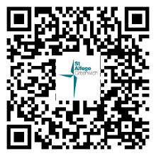
The collections at the special services over Advent and Christmas totalled £6,647.44 meaning that each of the three charities we supported will receive £2,215.81. Thank you for your generosity!

