

Sung Eucharist
Second Sunday of Epiphany
Sunday 18 January 2026
Welcome to our services of Holy Communion today. Revd Simon Winn, Vicar, is presiding and preaching at 8am and 10am. We sing together the Kyrie from Schubert’s German Mass (on page 2 of this sheet).
Readings
Isaiah 49: 1-7
Psalm 40: 1-12
1 Corinthians 1: 1-9
John 1: 29-42
Hymns
115 Dear Lord and Father of mankind
509 Rise and hear! The Lord is speaking
246 Just as I am, without one plea
180 Thou, whose almighty word
Collect
Almighty God, in Christ you make all things new: transform the poverty of our nature by the riches of your grace, and in the renewal of our lives make known your heavenly glory; through Jesus Christ your Son our Lord, who is alive and reigns with you, in the unity of the Holy Spirit, one God, now and for ever. Amen
Prayer after Communion
God of glory, you nourish us with your Word who is the bread of life: fill us with your Holy Spirit that through us the light of your glory may shine in all the world. We ask this in the name of Jesus Christ our Lord. Amen

Kyrie
We sing the Kyrie from Schubert’s German Mass
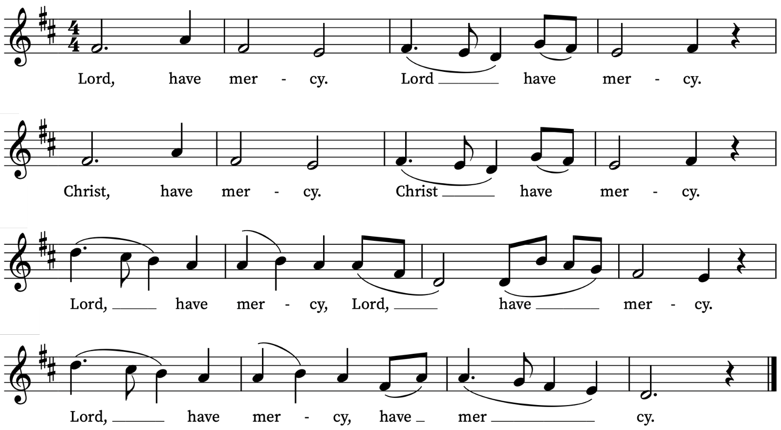
Old Testament Reading
Isaiah 49: 1-7
A reading from the Prophet Isaiah
Listen to me, O coastlands,
pay attention, you peoples from far away!
The Lord called me before I was born,
while I was in my mother’s womb he named me.
He made my mouth like a sharp sword,
in the shadow of his hand he hid me;
he made me a polished arrow,
in his quiver he hid me away.
And he said to me, ‘You are my servant,
Israel, in whom I will be glorified.’
But I said, ‘I have laboured in vain,
I have spent my strength for nothing and vanity;
yet surely my cause is with the Lord,
and my reward with my God.’
And now the Lord says,
who formed me in the womb to be his servant,
to bring Jacob back to him,
and that Israel might be gathered to him,
for I am honoured in the sight of the Lord,
and my God has become my strength—
he says,
‘It is too light a thing that you should be my servant
to raise up the tribes of Jacob
and to restore the survivors of Israel;
I will give you as a light to the nations,
that my salvation may reach to the end of the earth.’
Thus says the Lord,
the Redeemer of Israel and his Holy One,
to one deeply despised, abhorred by the nations,
the slave of rulers,
‘Kings shall see and stand up,
princes, and they shall prostrate themselves,
because of the Lord, who is faithful,
the Holy One of Israel, who has chosen you.’
This is the Word of the Lord
Thanks be to God
Psalm 40: 1-12
Expectans expectavi
I waited patiently for the Lord : and he inclined unto me, and heard my calling.
2 He brought me also out of the horrible pit, out of the mire and clay : and set my feet upon the rock, and ordered my goings.
3 And he hath put a new song in my mouth : even a thanksgiving unto our God.
4 Many shall see it, and fear : and shall put their trust in the Lord.
5 Blessed is the man that hath set his hope in the Lord : and turned not unto the proud, and to such as go about with lies.
6 O Lord my God, great are the wondrous works which thou hast done, like as be also thy thoughts which are to us-ward : and yet there is no man that ordereth them unto thee.
7 If I should declare them, and speak of them : they should be more than I am able to express.
8 Sacrifice and meat-offering thou wouldest not: but mine ears hast thou opened.
9 Burnt-offerings, and sacrifice for sin, hast thou not required : then said I, Lo, I come,
10 In the volume of the book it is written of me, that I should fulfil thy will, O my God : I am content to do it; yea, thy law is within my heart.
11 I have declared thy righteousness in the great congregation : lo, I will not refrain my lips, O Lord, and that thou knowest.
12 I have not hid thy righteousness within my heart : my talk hath been of thy truth and of thy salvation.
New Testament Reading
1 Corinthians 1: 1-9
A reading from the First Letter to the Corinthians
Paul, called to be an apostle of Christ Jesus by the will of God, and our brother Sosthenes,
To the church of God that is in Corinth, to those who are sanctified in Christ Jesus, called to be saints, together with all those who in every place call on the name of our Lord Jesus Christ, both their Lord and ours:
Grace to you and peace from God our Father and the Lord Jesus Christ.
I give thanks to my God always for you because of the grace of God that has been given you in Christ Jesus, for in every way you have been enriched in him, in speech and knowledge of every kind— just as the testimony of Christ has been strengthened among you— so that you are not lacking in any spiritual gift as you wait for the revealing of our Lord Jesus Christ. He will also strengthen you to the end, so that you may be blameless on the day of our Lord Jesus Christ. God is faithful; by him you were called into the fellowship of his Son, Jesus Christ our Lord.
This is the Word of the Lord
Thanks be to God
Gospel Reading
John 1: 29-42
Alleluia, alleluia.
Christ was revealed in the flesh, proclaimed among the nations
And believed in throughout the world.
Alleluia
Hear the Gospel of our Lord Jesus Christ according to John
Glory be to thee, O Lord
The next day John saw Jesus coming towards him and declared, ‘Here is the Lamb of God who takes away the sin of the world! This is he of whom I said, “After me comes a man who ranks ahead of me because he was before me.” I myself did not know him; but I came baptizing with water for this reason, that he might be revealed to Israel.’ And John testified, ‘I saw the Spirit descending from heaven like a dove, and it remained on him. I myself did not know him, but the one who sent me to baptize with water said to me, “He on whom you see the Spirit descend and remain is the one who baptizes with the Holy Spirit.” And I myself have seen and have testified that this is the Son of God.’
The next day John again was standing with two of his disciples, and as he watched Jesus walk by, he exclaimed, ‘Look, here is the Lamb of God!’ The two disciples heard him say this, and they followed Jesus. When Jesus turned and saw them following, he said to them, ‘What are you looking for?’ They said to him, ‘Rabbi’ (which translated means Teacher), ‘where are you staying?’ He said to them, ‘Come and see.’ They came and saw where he was staying, and they remained with him that day. It was about four o’clock in the afternoon. One of the two who heard John speak and followed him was Andrew, Simon Peter’s brother. He first found his brother Simon and said to him, ‘We have found the Messiah’ (which is translated Anointed). He brought Simon to Jesus, who looked at him and said, ‘You are Simon son of John. You are to be called Cephas’ (which is translated Peter).
This is the Gospel of the Lord
Praise be to thee, O Christ
Today’s Music
Mass setting
Mass for Five Voices – William Byrd
Anthem
O for a closer walk with God – C.V. Stanford
O for a closer walk with God, a calm and heavenly frame; a light to shine upon the road that leads me to the Lamb!
Return, O holy dove, return, sweet messenger of rest; I hate the sins that made thee mourn, and drove thee from my breast.
So shall my walk be close with God, calm and serene my frame; so purer light shall mark the road that leads me to the Lamb.
Communion
Agnus Dei from Mass for Five Voices – William Byrd
Tu es Petrus – Maurice Duruflé
Thou art Peter, and upon this rock I will build my church,
and the gates of hell shall not prevail against it.
And I will give unto thee the keys of the kingdom of heaven.
Matthew 16:18,19
Organ Postlude
Marche des Rois Mages – Théodore Dubois
Prayers for the week
We pray for those in need: Anthony, Fran Barlow, Ian Clark, Helen and Dan Delap, Delroy Donegal, Andrew Fraser, Hessie and Nick Hervey, Carole Hubble, Nancy John, Lena Kimming, Lylian Meira, Nancy Mence, Nimal Menon, Nicola Orme, Tony Othen, Vinubhai Patel, Jessica Springbett, Jean Smith, Tina Stanley, Jessica Tipton, Sabrina Unold, George Voelker, Pauline Youll, and Joshua Zitha.
We remember those who have died recently, including Gordon Anderson, Faith Clarke, David Donaghy, Ken Eastwood, Christopher Follett, Eva Preisich, Aminta Prowse and David Weaver. We also remember Alan Munden on his year’s mind. We ask God’s blessing and comfort on all mourning the loss of loved ones.
To include names of loved ones on the prayer list, please contact David McEvoy dmcevoy@btinternet.com
Please note that we will be starting afresh with the list of names of those who are ill or in need from Sunday 15 February. If you would like to retain (or add) names of loved ones on the list please email David McEvoy with the names by Wednesday 11 February.

Supporting St Alfege Church
Please do make a gift to support the life and ministry of St Alfege Church – during the collection in the service or by using a card reader at the North and West Doors. Please complete a Gift Aid envelope (if you are eligible) whether you donate by cash or card. You can also use this QR code to donate. | 

Services this Week
Sunday 18 January Second Sunday of Epiphany
8.00am Holy Communion (Said) (Book of Common Prayer)
10.00am Sung Eucharist and Children’s Church
Monday 19 January
8.30am Morning Prayer
Tuesday 20 January
8.30am Morning Prayer
Wednesday 21 January
8.30am Morning Prayer
11.30am Funeral of Faith Clarke
Thursday 22 January
8.30am Morning Prayer
Saturday 24 January
3.30pm A free concert to celebrate the life of Gillian duCharme
Sunday 25 January Third Sunday of Epiphany
8.00am Holy Communion (Said) (Book of Common Prayer)
10.00am Sung Eucharist and Children’s Church
4.00pm Choral Evensong (please note new time)
Walk-in Wednesdays
Every Wednesday 10am-12noon in the small hall
Contact us
Vicar: Revd Simon Winn
Curate: Revd Dr Tati Gutteridge (on maternity leave)
Church Office: 020 8853 0687
Email: office@st-alfege.org.uk Website: www.st-alfege.org.uk
Safeguarding Team
Karen Hansen Lead Safeguarding Officer 07866 932 894
Carole Moses Safeguarding Officer 07889 396 671
Irene Bishop Safeguarding Officer 020 8698 2658
safeguarding@st-alfege.org.uk

