

Sung Eucharist
Fourth Sunday of Easter
Marathon Sunday
26 April 2026
Welcome to our services of Holy Communion. Revd Simon Winn, Vicar is presiding and David McEvoy, Reader, is preaching at 8am and10am.
Readings
Acts2: 42-47
Psalm 23
1 Peter 2: 19-25
John 10: 1-10
Hymns
83 Love’s redeeming work is done
This joyful Eastertide (on page 4 of this sheet)
126 The king of love
234 Thine for ever! God of love
Collect
Almighty God, whose Son Jesus Christ is the resurrection and the life: raise us, who trust in him, from the death of sin to the life of righteousness, that we may seek those things which are above, where he reigns with you in the unity of the Holy Spirit, one God, now and for ever. Amen
Prayer after Communion
Merciful Father, you gave your Son Jesus Christ to be the good shepherd, and in his love for us to lay down his life and rise again: keep us always under his protection, and give us grace to follow in his steps; through Jesus Christ our Lord. Amen
Kyrie
We join in singing the Kyrie from Schubert’s German Mass:
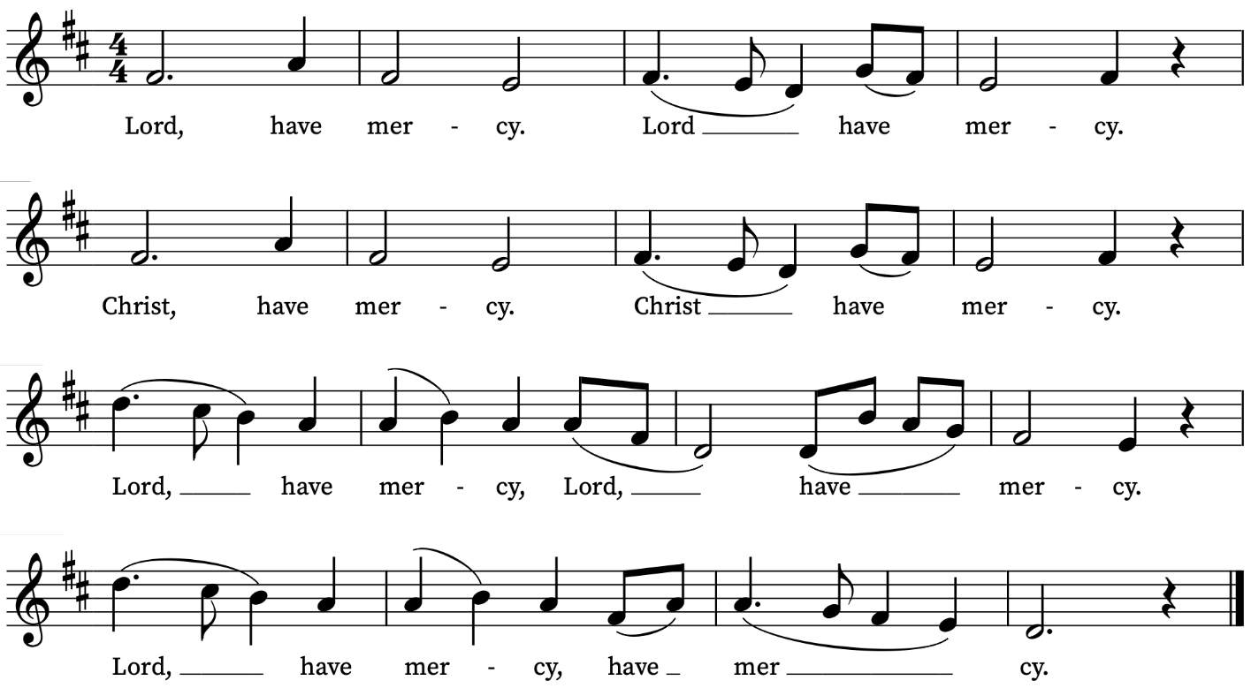
Old Testament Reading
Acts 2: 42-47
A reading from the Acts of the Apostles
The believers devoted themselves to the apostles’ teaching and fellowship, to the breaking of bread and the prayers.
Awe came upon everyone, because many wonders and signs were being done by the apostles. All who believed were together and had all things in common; they would sell their possessions and goods and distribute the proceeds to all, as any had need. Day by day, as they spent much time together in the temple, they broke bread at home and ate their food with glad and generous hearts, praising God and having the goodwill of all the people. And day by day the Lord added to their number those who were being saved.
This is the Word of the Lord
Thanks be to God
Psalm 23
Dominus regit me.
The Lord is my shepherd : therefore can I lack nothing.
2 He shall feed me in a green pasture : and lead me forth beside the waters of comfort.
3 He shall convert my soul : and bring me forth in the paths of righteousness, for his Name's sake.
4 Yea, though I walk through the valley of the shadow of death, I will fear no evil : for thou art with me; thy rod and thy staff comfort me.
5 Thou shalt prepare a table before me against them that trouble me : thou hast anointed my head with oil, and my cup shall be full.
6 Surely thy loving-kindness and mercy shall follow me all the days of my life : and I will dwell in the house of the Lord for ever.
New Testament Reading
1 Peter 2: 19-25
A reading from the First Letter of Peter
For it is to your credit if, being aware of God, you endure pain while suffering unjustly. If you endure when you are beaten for doing wrong, where is the credit in that? But if you endure when you do right and suffer for it, you have God’s approval. For to this you have been called, because Christ also suffered for you, leaving you an example, so that you should follow in his steps.
‘He committed no sin,
and no deceit was found in his mouth.’
When he was abused, he did not return abuse; when he suffered, he did not threaten; but he entrusted himself to the one who judges justly. He himself bore our sins in his body on the cross, so that, free from sins, we might live for righteousness; by his wounds you have been healed. For you were going astray like sheep, but now you have returned to the shepherd and guardian of your souls.
This is the Word of the Lord
Thanks be to God
Gradual Hymn
This joyful Eastertide,
away with sin and sorrow.
My love, the Crucified,
hath sprung to life this morrow.
Refrain:
Had Christ, that once was slain,
ne’er burst his three-day prison,
our faith had been in vain:
but now hath Christ arisen,
arisen, arisen, arisen.
My flesh in hope shall rest,
and for a season slumber;
till trump from east to west
shall wake the dead in number.
Refrain
Death’s flood hath lost its chill,
since Jesus crossed the river:
lover of souls, from ill
my passing soul deliver.
Refrain
George Ratcliffe Woodward (1848-1934)
Traditional Dutch melody

Gospel Reading
John 10: 1-10
Hear the Gospel of our Lord Jesus Christ according to John.
Glory be to thee, O Lord
Jesus said: ‘Very truly, I tell you, anyone who does not enter the sheepfold by the gate but climbs in by another way is a thief and a bandit. The one who enters by the gate is the shepherd of the sheep. The gatekeeper opens the gate for him, and the sheep hear his voice. He calls his own sheep by name and leads them out. When he has brought out all his own, he goes ahead of them, and the sheep follow him because they know his voice. They will not follow a stranger, but they will run from him because they do not know the voice of strangers.’ Jesus used this figure of speech with them, but they did not understand what he was saying to them.
So again Jesus said to them, ‘Very truly, I tell you, I am the gate for the sheep. All who came before me are thieves and bandits; but the sheep did not listen to them. I am the gate. Whoever enters by me will be saved, and will come in and go out and find pasture. The thief comes only to steal and kill and destroy. I came that they may have life, and have it abundantly.
This is the Gospel of the Lord
Praise be to thee, O Christ

Today’s Music
Mass setting (Gloria, Sanctus/Benedictus and Agnus Dei):
Communion Service in C – John Ireland
Anthem
Ye Choirs of new Jerusalem – C.V. Stanford
Ye choirs of new Jerusalem, Your sweetest notes employ,
The Paschal victory to hymn In strains of holy joy.
For Judah's Lion bursts His chains, Crushing the serpent's head;
And cries aloud through death’s domains To wake th'imprison'd dead.
Devouring depths of hell Their prey at His command restore;
His ransom'd hosts pursue their way Where Jesus goes before.
Triumphant in His glory now To Him all power is given;
To Him in one communion bow All saints in earth and heaven.
While we, His soldiers, praise our King, His mercy we implore,
Within His palace bright to bring And keep us evermore.
All glory to the Father be, All glory to the Son,
All glory, Holy Ghost, to Thee, While endless ages run.
Alleluia! Amen.
Communion
Haec dies from– William Byrd
Haec dies quam fecit Dominus:
exultemus et laetemur in ea,
Alleluia.
This is the day the Lord has made:
let us rejoice and be glad in it,
Alleluia.
(Psalm 118:24)
Organ Postlude
The Bells – William Byrd
Prayers for the week
We pray for those in need: Helen Delap, Dan Delap, Delroy Donegal, Susan and Anthony Holland, Carole Hubble, Sara Mauleverer, Lylian Meira, Vernon Mustoe, Jim Odell, Nicola Orme, Jessica Springbett, Jean Smith, Tina Stanley, and Pauline Youll.
We remember those who have died recently, including Ian Clark, Joel Coleman, Anthony Durham, Brenda Eva (née Price), Lesley Hodsdon, Jeff Hurst, Peter King, Roger Matthews, Doreen McAree, and Richard Pulkowski. We ask God’s blessing and comfort on Eleanor Clark and all mourning the loss of loved ones.
If you wish to add names to the prayers for those in need or departed please contact David McEvoy dmcevoy@btinternet.com
Supporting St Alfege Church
Please do make a gift to support the life and ministry of St Alfege Church – during the collection in the service or by using a card reader at the North and West Doors. Please complete a Gift Aid envelope (if you are eligible) whether you donate by cash or card. You can also use this QR code to donate. | 

Services this week
Sunday 26 April Fourth Sunday of Easter
8am Holy Communion (Book of Common Prayer)
10am Sung Eucharist
4.00pm Choral Evensong
Monday 27 April
8.30am Morning Prayer (in the Small Hall, church hall)
10am Funeral of Peter King

Tuesday 28 April
8.30am Morning Prayer (in the Small Hall)
Wednesday 29April
8.30am Morning Prayer (in the Small Hall)
Thursday 30 April
8.00am Holy Communion (In the Small Hall)
Sunday 3 May Fifth Sunday of Easter
8am Holy Communion (Book of Common Prayer)
10am Sung Eucharist
5.30pm Abide, a contemplative service with music from the Taizé tradition.
Walk-in Wednesdays
Every Wednesday 10am-12noon in the small hall
Contact us
Vicar: Revd Simon Winn
Curate: Revd Dr Tati Gutteridge (on maternity leave)
Church Office: 020 8853 0687
Email: office@st-alfege.org.uk Website: www.st-alfege.org.uk
Safeguarding Team
Karen Hansen Lead Safeguarding Officer 07866 932 894
Carole Moses Safeguarding Officer 07889 396 671
Irene Bishop Safeguarding Officer 020 8698 2658
safeguarding@st-alfege.org.uk

