

Sung Eucharist
Sunday after Ascension
17 May 2026
Welcome to our services of Holy Communion. Revd Dr Robert Tobin is presiding and preaching at 8am. We welcome Revd Kevin Parkes as president and preacher at 10am.
Readings
Acts 1: 6-14
Psalm 68: 1-10
1 Peter 4: 12-14; 5: 6-11
John 17: 1-11
Hymns
141 The head that once was crowned with thorns
460 Give to our God immortal praise (Tallis’s Canon)
262 Alleluia, sing to Jesus
139 Rejoice, the Lord is king
Collect
O God the King of glory, you have exalted your only Son Jesus Christ with great triumph to your kingdom in heaven:
we beseech you, leave us not comfortless, but send your Holy Spirit to strengthen us and exalt us to the place where our Saviour Christ is gone before, who is alive and reigns with you, in the unity of the Holy Spirit, one God, now and for ever. Amen
Prayer after Communion
Eternal God, giver of love and power, your Son Jesus Christ has sent us into all the world to preach the gospel of his kingdom: confirm us in this mission, and help us to live the good news we proclaim; through Jesus Christ our Lord. Amen
Kyrie
We join in singing the Kyrie from Schubert’s German Mass:
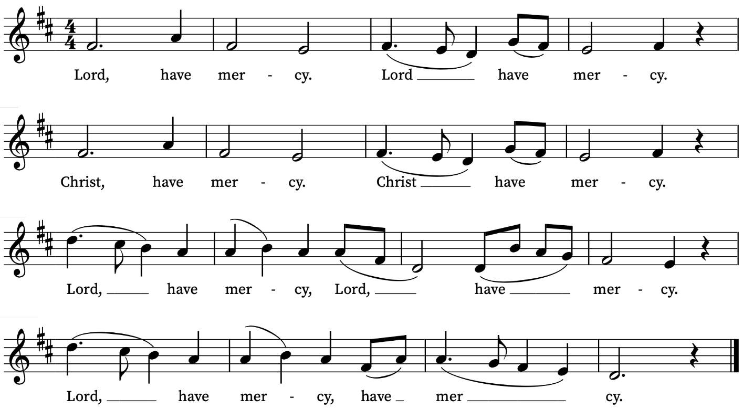
First Reading
Acts 1: 6-14
A reading from the Acts of the Apostles
So when they had come together, they asked him, ‘Lord, is this the time when you will restore the kingdom to Israel?’ He replied, ‘It is not for you to know the times or periods that the Father has set by his own authority. But you will receive power when the Holy Spirit has come upon you; and you will be my witnesses in Jerusalem, in all Judea and Samaria, and to the ends of the earth.’ When he had said this, as they were watching, he was lifted up, and a cloud took him out of their sight. While he was going and they were gazing up towards heaven, suddenly two men in white robes stood by them. They said, ‘Men of Galilee, why do you stand looking up towards heaven? This Jesus, who has been taken up from you into heaven, will come in the same way as you saw him go into heaven.’

Then they returned to Jerusalem from the mount called Olivet, which is near Jerusalem, a sabbath day’s journey away. When they had entered the city, they went to the room upstairs where they were staying, Peter, and John, and James, and Andrew, Philip and Thomas, Bartholomew and Matthew, James son of Alphaeus, and Simon the Zealot, and Judas son of James. All these were constantly devoting themselves to prayer, together with certain women, including Mary the mother of Jesus, as well as his brothers.
This is the Word of the Lord
Thanks be to God
Psalm 68: 1-10, 32- 35
Exurgat Deus
Let God arise, and let his enemies be scattered let them also that hate him flee before him.
2 Like as the smoke vanisheth, so shalt thou drive them away : and like as wax melteth at the fire, so let the ungodly perish at the presence of God.
3 But let the righteous be glad and rejoice before God : let them also be merry and joyful.
4 O sing unto God, and sing praises unto his Name : magnify him that rideth upon the heavens, as it were upon an horse; praise him in his Name jah, and rejoice before him.
5 He is a father of the fatherless, and defendeth the cause of the widows : even God in his holy habitation.
6 He is the God that maketh men to be of one mind in an house, and bringeth the prisoners out of captivity : but letteth the runagates continue in scarceness.
7 O God, when thou wentest forth before the people : when thou wentest through the wilderness;
8 The earth shook, and the heavens dropped at the presence of God : even as Sinai also was moved at the presence of God, who is the God of Israel.
9 Thou, O God, sentest a gracious rain upon thine inheritance : and refreshedst it when it was weary.
10 Thy congregation shall dwell therein : for thou, O God, hast of thy goodness prepared for the poor.
32 Sing unto God, O ye kingdoms of the earth : O sing praises unto the Lord;
33 Who sitteth in the heavens over all from the beginning : lo, he doth send out his voice, yea, and that a mighty voice.
34 Ascribe ye the power to God over Israel : his worship and strength is in the clouds.
35 O God, wonderful art thou in thy holy places : even the God of Israel, he will give strength and power unto his people; blessed be God
Second Reading
1 Peter 4: 12-14; 5: 6-11
A reading from the First Letter of Peter
Beloved, do not be surprised at the fiery ordeal that is taking place among you to test you, as though something strange were happening to you. But rejoice in so far as you are sharing Christ’s sufferings, so that you may also be glad and shout for joy when his glory is revealed. If you are reviled for the name of Christ, you are blessed, because the spirit of glory, which is the Spirit of God, is resting on you.
Humble yourselves therefore under the mighty hand of God, so that he may exalt you in due time. Cast all your anxiety on him, because he cares for you. Discipline yourselves; keep alert. Like a roaring lion your adversary the devil prowls around, looking for someone to devour. Resist him, steadfast in your faith, for you know that your brothers and sisters throughout the world are undergoing the same kinds of suffering. And after you have suffered for a little while, the God of all grace, who has called you to his eternal glory in Christ, will himself restore, support, strengthen, and establish you. To him be the power for ever and ever. Amen.
This is the Word of the Lord
Thanks be to God
Gospel Reading
John 17: 1-11
Hear the Gospel of our Lord Jesus Christ according to John
Glory be to thee, O Lord
After Jesus had spoken these words, he looked up to heaven and said, ‘Father, the hour has come; glorify your Son so that the Son may glorify you, since you have given him authority over all people,
to give eternal life to all whom you have given him. And this is eternal life, that they may know you, the only true God, and Jesus Christ whom you have sent. I glorified you on earth by finishing the work that you gave me to do. So now, Father, glorify me in your own presence with the glory that I had in your presence before the world existed.
‘I have made your name known to those whom you gave me from the world. They were yours, and you gave them to me, and they have kept your word. Now they know that everything you have given me is from you; for the words that you gave to me I have given to them, and they have received them and know in truth that I came from you; and they have believed that you sent me. I am asking on their behalf; I am not asking on behalf of the world, but on behalf of those whom you gave me, because they are yours. All mine are yours, and yours are mine; and I have been glorified in them. And now I am no longer in the world, but they are in the world, and I am coming to you. Holy Father, protect them in your name that you have given me, so that they may be one, as we are one.
This is the Gospel of the Lord
Praise be to thee, O Christ
Today’s Music
Mass setting: (Gloria, Sanctus/Benedictus and Agnus Dei):
Missa in G – Josef Rheinberger
Anthem
O clap your hands – Ralph Vaughan Williams
O clap your hands, all ye people;
shout unto God with the voice of triumph.
For the Lord most high is terrible.
He is a great King over all the earth.
God is gone up with a shout,
the Lord with the sound of a trumpet.
Sing praises to God; sing praises.
Sing praises to our King; sing praises.
For God is the King of all the earth.
Sing ye praises with understanding.
God reigneth over the heathen.
God sitteth upon the throne of His holiness.
Sing praises unto our King. Sing praises.
Psalm 47.1-8
Communion
Agnus Dei from Missa in G – Josef Rheinberger
Ascendit Deus – Peter Philips
Ascendit Deus in iubilatione, et Dominus in vocae tubae. Alleluia.
Dominus in caelo paravit sedem suam. Alleluia.
God is gone up with a shout, the Lord with the sound of a trumpet. Alleluia.
The Lord hath prepared his throne in heaven. Alleluia.
Psalm 47: 5; 103: 19
Organ Postlude
Prelude and Fugue in G major BWV 541 – J.S. Bach
Prayers for the week
We pray for those in need: Helen Delap, Dan Delap, Delroy Donegal, Bill Essex, Susan and Anthony Holland, Carole Hubble, Marion Kokott, Sara Mauleverer, Lylian Meira, Vernon Mustoe, Jim Odell, Nicola Orme, Penny Saunders, Jean Smith, Tina Stanley, and Pauline Youll.
We remember those who have died recently, including Joe Bennett, Ian Clark, Joel Coleman, Anthony Durham, Brenda Eva (née Price), Doreen McAree, Jessica Springbett, and Richard Winn. We ask God’s blessing and comfort on all mourning the loss of loved ones.
If you wish to add names to the prayers for those in need or departed please contact David McEvoy dmcevoy@btinternet.com
Supporting St Alfege Church
Please do make a gift to support the life and ministry of St Alfege Church – during the collection in the service or by using a card reader at the North and West Doors. Please complete a Gift Aid envelope (if you are eligible) whether you donate by cash or card. You can also use this QR code to donate. | 
Services this week
Sunday 17 May Sunday after Ascension
8am Holy Communion (Book of Common Prayer)
10am Sung Eucharist
Monday 18 May
8.30am Morning Prayer
Tuesday 19 May
8.30am Morning Prayer
Wednesday 20 May
8.30am Morning Prayer
Thursday 21 May
8.00am Holy Communion
Sunday 24 May Pentecost
8am Holy Communion (Book of Common Prayer)
10am Sung Eucharist
Walk-in Wednesdays
Every Wednesday 10am-12noon in the small hall
Contact us
Vicar: Revd Simon Winn
Curate: Revd Dr Tati Gutteridge (on maternity leave)
Church Office: 020 8853 0687
Email: office@st-alfege.org.uk Website: www.st-alfege.org.uk
Safeguarding Team
Karen Hansen Lead Safeguarding Officer 07866 932 894
Carole Moses Safeguarding Officer 07889 396 671
Irene Bishop Safeguarding Officer 020 8698 2658
safeguarding@st-alfege.org.uk

