

Sung Eucharist
First Sunday after Trinity
7 June 2026
Welcome to our services of Holy Communion. Revd Simon Winn, Vicar, is presiding and preaching at 8am and 10am. Children’s church meet in the church hall at 10am.
Readings
Hosea 5:15 – 6:6
Psalm 50: 7-15
Romans 4: 13-25
Matthew 9: 9-13, 18-26
Hymns
148 At the name of Jesus
312 Jesus calls us o’er the tumult
257 Deck thyself, my soul, with gladness
265 O thou, who at thy Eucharist didst pray
Collect
O God, the strength of all those who put their trust in you,
mercifully accept our prayers and, because through the weakness of our mortal nature we can do no good thing without you, grant us the help of your grace, that in the keeping of your commandments we may please you both in will and deed; through Jesus Christ your Son our Lord, who is alive and reigns with you, in the unity of the Holy Spirit, one God, now and for ever. Amen
Prayer after Communion
Eternal Father, we thank you for nourishing us with these heavenly gifts: may our communion strengthen us in faith, build us up in hope, and make us grow in love; for the sake of Jesus Christ our Lord. Amen
Kyrie
We join in singing the Kyrie from Schubert’s German Mass:
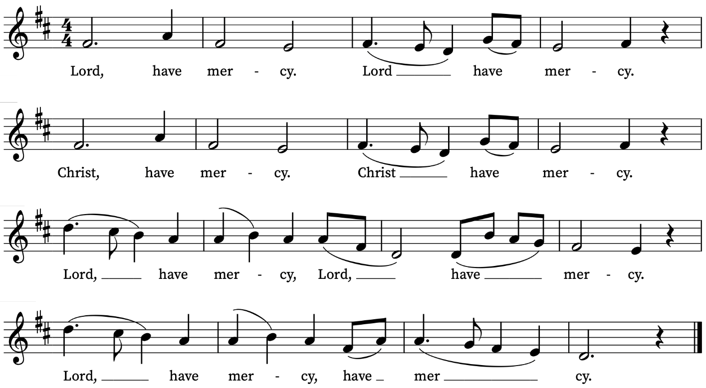
First Reading
Hosea 5:15 – 6:6
A reading from the Prophet Hosea
I will return again to my place
until they acknowledge their guilt and seek my face.
In their distress they will beg my favour:
‘Come, let us return to the Lord;
for it is he who has torn, and he will heal us;
he has struck down, and he will bind us up.
After two days he will revive us;
on the third day he will raise us up,
that we may live before him.
Let us know, let us press on to know the Lord;
his appearing is as sure as the dawn;
he will come to us like the showers,
like the spring rains that water the earth.’
What shall I do with you, O Ephraim?
What shall I do with you, O Judah?
Your love is like a morning cloud,
like the dew that goes away early.
Therefore I have hewn them by the prophets,
I have killed them by the words of my mouth,
and my judgement goes forth as the light.
For I desire steadfast love and not sacrifice,
the knowledge of God rather than burnt-offerings.
This is the Word of the Lord
Thanks be to God
Psalm 50: 7-15
7 Hear, O my people, and I will speak : I myself will testify against thee, O Israel; for I am God, even thy God.
8 I will not reprove thee because of thy sacrifices, or for thy burnt-offerings : because they were not alway before me.
9 I will take no bullock out of thine house : nor he-goat out of thy folds.
10 For all the beasts of the forest are mine : and so are the cattle upon a thousand hills.
11 I know all the fowls upon the mountains : and the wild beasts of the field are in my sight.
12 If I be hungry, I will not tell thee : for the whole world is mine, and all that is therein.
13 Thinkest thou that I will eat bulls' flesh : and drink the blood of goats?
14 Offer unto God thanksgiving : and pay thy vows unto the most Highest.
15 And call upon me in the time of trouble : so will I hear thee, and thou shalt praise me.

Second Reading
Romans 4: 13-25
A reading from Paul’s Letter to the Romans
For the promise that he would inherit the world did not come to Abraham or to his descendants through the law but through the righteousness of faith. If it is the adherents of the law who are to be the heirs, faith is null and the promise is void. For the law brings wrath; but where there is no law, neither is there violation.
For this reason it depends on faith, in order that the promise may rest on grace and be guaranteed to all his descendants, not only to the adherents of the law but also to those who share the faith of Abraham (for he is the father of all of us, as it is written, ‘I have made you the father of many nations’)—in the presence of the God in whom he believed, who gives life to the dead and calls into existence the things that do not exist. Hoping against hope, he believed that he would become ‘the father of many nations’, according to what was said, ‘So numerous shall your descendants be.’ He did not weaken in faith when he considered his own body, which was already as good as dead (for he was about a hundred years old), or when he considered the barrenness of Sarah’s womb. No distrust made him waver concerning the promise of God, but he grew strong in his faith as he gave glory to God, being fully convinced that God was able to do what he had promised. Therefore his faith ‘was reckoned to him as righteousness.’ Now the words, ‘it was reckoned to him’, were written not for his sake alone, but for ours also. It will be reckoned to us who believe in him who raised Jesus our Lord from the dead, who was handed over to death for our trespasses and was raised for our justification.
This is the Word of the Lord
Thanks be to God

Gospel Reading
Matthew 9: 9-13,18-26
Hear the Gospel of our Lord Jesus Christ according to Matthew
Glory be to thee, O Lord
As Jesus was walking along, he saw a man called Matthew sitting at the tax booth; and he said to him, ‘Follow me.’ And he got up and followed him.
And as he sat at dinner in the house, many tax-collectors and sinners came and were sitting with him and his disciples. When the Pharisees saw this, they said to his disciples, ‘Why does your teacher eat with tax-collectors and sinners?’ But when he heard this, he said, ‘Those who are well have no need of a physician, but those who are sick. Go and learn what this means, “I desire mercy, not sacrifice.” For I have come to call not the righteous but sinners.’
While he was saying these things to them, suddenly a leader of the synagogue came in and knelt before him, saying, ‘My daughter has just died; but come and lay your hand on her, and she will live.’ And Jesus got up and followed him, with his disciples. Then suddenly a woman who had been suffering from haemorrhages for twelve years came up behind him and touched the fringe of his cloak, for she said to herself, ‘If I only touch his cloak, I will be made well.’ Jesus turned, and seeing her he said, ‘Take heart, daughter; your faith has made you well.’ And instantly the woman was made well. When Jesus came to the leader’s house and saw the flute-players and the crowd making a commotion, he said, ‘Go away; for the girl is not dead but sleeping.’ And they laughed at him. But when the crowd had been put outside, he went in and took her by the hand, and the girl got up. And the report of this spread throughout that district.
This is the Gospel of the Lord
Praise be to thee, O Christ

Today’s Music
Mass setting: (Gloria, Sanctus/Benedictus and Agnus Dei):
Communion Service in F – Harold Darke
Anthem
Lauda Sion (opening) – Felix Mendelssohn
Lauda Sion Salvatórem
Lauda ducem et pastórem
In hymnis et cánticis.
Quantum potes, tantum aude,
Quia major omni laude,
Nec laudáre súfficis.
‍O Zion, praise your Savior!
Praise your prince and your shepherd
With hymns and songs.
Dare to do as much as you can,
For he is greater than all praise,
And you do not do enough to praise him.
Communion
Agnus Dei from Communion Service in F – Harold Darke
O sacrum convivium – Olivier Messiaen
O sacrum convivium, in quo Christus sumitur,
recolitur memoria passionis eius:
mens impletur gratia, et futuræ gloriæ nobis pignus datur.
O sacred banquet, in which Christ is received,
the memory of his Passion is renewed:
the mind is filled with grace, and the promise of future glory is given to us.
Words: attrib. Thomas Aquinas
(Antiphon for Vespers on the Feast of Corpus Christi)
Organ Postlude
Dankpsalm – Max Reger

Prayers for the week
We pray for those in need: Helen Delap, Dan Delap, Delroy Donegal, Bill Essex, Susan and Anthony Holland, Carole Hubble, Marion Kokott, James Markham, Sara Mauleverer, Lylian Meira, Vernon Mustoe, Nicola Orme, Peter Saunders, Philip Simms, Jean Smith, Tina Stanley, and Pauline Youll.
We remember those who have died recently, including Joe Bennett, Joel Coleman, Anthony Durham, Brenda Eva (née Price), Mary Kinnison, Doreen McAree, Jana Georgieva, Luis Segui Gimeno and Richard Winn. We also remember Simon Foreman, Peter Hutchins, Michelle Nozarick, and Phyllis Thorley on their year’s minds. We ask God’s comfort on all mourning the loss of loved ones.
If you wish to add names to the prayers for those in need or departed please contact David McEvoy dmcevoy@btinternet.com
Supporting St Alfege Church
Please do make a gift to support the life and ministry of St Alfege Church – during the collection in the service or by using a card reader at the North and West Doors. Please complete a Gift Aid envelope (if you are eligible) whether you donate by cash or card. You can also use this QR code to donate.  Abide service tonight Sunday 7 June at 5.30pm  Do join us for our service this evening. Abide is a contemplative service with music from the Taizé tradition. The theme today will be God’s presence in the whole of creation. The service will be outdoors weather permitting. | 
Services this week
Sunday 7 June First Sunday after Trinity
8am Holy Communion (Book of Common Prayer)
10am Sung Eucharist
5.30pm Abide, a contemplative service with music from the Taizé tradition. The theme will be God’s presence in the whole of creation. The service will be outdoors weather permitting.
Monday 8 June
8.30am Morning Prayer
Tuesday 9 June
8.30am Morning Prayer
Wednesday 10 June
8.30am Morning Prayer
Thursday 11 June
8.00am Holy Communion
Sunday 14 June First Sunday after Trinity
8am Holy Communion (Book of Common Prayer)
10am Sung Eucharist
Walk-in Wednesdays
Every Wednesday 10am-12noon in the small hall
Contact us
Vicar: Revd Simon Winn
Curate: Revd Dr Tati Gutteridge (on maternity leave)
Church Office: 020 8853 0687
Email: office@st-alfege.org.uk Website: www.st-alfege.org.uk
Safeguarding Team
Karen Hansen Lead Safeguarding Officer 07866 932 894
Carole Moses Safeguarding Officer 07889 396 671
Irene Bishop Safeguarding Officer 020 8698 2658
safeguarding@st-alfege.org.uk

