
x

Sung Eucharist
Fourteenth Sunday after Trinity
6 September 2026
Welcome to our services of Holy Communion. Revd Simon Winn is presiding and preaching at 8am and 10am. We welcome back the choir and children's church after their summer break. At the end of the 10am service Revd Simon will bless backpacks and pray for all beginning a new academic year. We will all sing the Kyrie (on page 2 of this sheet). Revd Dr Tati Gutteridge is leading Children’s Church Holy Communion in the hall.
Readings
Ezekiel 33: 7-11
Psalm 119: 33-40
Romans 13: 8-end
Matthew 18: 15-20
Hymns
160 We love the place, O God
178 Thy kingdom come! on bended knee
263 Lord, enthroned in heavenly splendour (first tune)
God of our learning (Bunessan) on page 5 of this sheet
Collect
Almighty God, whose only Son has opened for us a new and living way into your presence: give us pure hearts and steadfast wills to worship you in spirit and in truth; through Jesus Christ your Son our Lord, who is alive and reigns with you, in the unity of the Holy Spirit, one God, now and for ever. Amen
Prayer after Communion
Lord God, the source of truth and love, keep us faithful to the apostles’ teaching and fellowship, united in prayer and the breaking of bread, and one in joy and simplicity of heart,
in Jesus Christ our Lord. Amen
Kyrie
Please join in singing the Kyrie from Schubert’s German Mass.
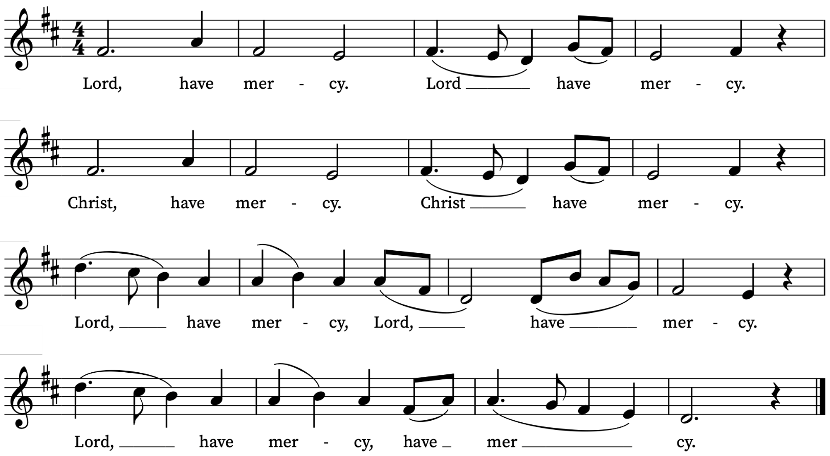

First Reading
Ezekiel 33: 7-11
A reading from the Prophet Ezekiel
So you, mortal, I have made a sentinel for the house of Israel; whenever you hear a word from my mouth, you shall give them warning from me. If I say to the wicked, ‘O wicked ones, you shall surely die’, and you do not speak to warn the wicked to turn from their ways, the wicked shall die in their iniquity, but their blood I will require at your hand. But if you warn the wicked to turn from their ways, and they do not turn from their ways, the wicked shall die in their iniquity, but you will have saved your life.
Now you, mortal, say to the house of Israel, Thus you have said: ‘Our transgressions and our sins weigh upon us, and we waste away because of them; how then can we live?’ Say to them, As I live, says the Lord God, I have no pleasure in the death of the wicked, but that the wicked turn from their ways and live; turn back, turn back from your evil ways; for why will you die, O house of Israel?
This is the Word of the Lord
Thanks be to God
Psalm 119: 33-40
Legem pone
Teach me, O Lord, the way of thy statutes : and I shall keep it unto the end.
34 Give me understanding, and I shall keep thy law : yea, I shall keep it with my whole heart.
35 Make me to go in the path of thy commandments : for therein is my desire.
36 Incline my heart unto thy testimonies : and not to covetousness.
37 O turn away mine eyes, lest they behold vanity : and quicken thou me in thy way.
38 O stablish thy word in thy servant : that I may fear thee.
39 Take away the rebuke that I am afraid of : for thy judgements are good.
40 Behold, my delight is in thy commandments : O quicken me in thy righteousness.

Second Reading
Romans 13: 8-14
A reading from Paul’s Letter to the Romans
Owe no one anything, except to love one another; for the one who loves another has fulfilled the law. The commandments, ‘You shall not commit adultery; You shall not murder; You shall not steal; You shall not covet’; and any other commandment, are summed up in this word, ‘Love your neighbour as yourself.’ Love does no wrong to a neighbour; therefore, love is the fulfilling of the law.
Besides this, you know what time it is, how it is now the moment for you to wake from sleep. For salvation is nearer to us now than when we became believers; the night is far gone, the day is near. Let us then lay aside the works of darkness and put on the armour of light; let us live honourably as in the day, not in revelling and drunkenness, not in debauchery and licentiousness, not in quarrelling and jealousy. Instead, put on the Lord Jesus Christ, and make no provision for the flesh, to gratify its desires.
This is the Word of the Lord
Thanks be to God
Gospel Reading
Matthew 18: 15-20
Hear the Gospel of our Lord Jesus Christ according to Matthew
Glory be to thee, O Lord
Jesus said: ‘If another member of the church sins against you, go and point out the fault when the two of you are alone. If the member listens to you, you have regained that one. But if you are not listened to, take one or two others along with you, so that every word may be confirmed by the evidence of two or three witnesses. If the member refuses to listen to them, tell it to the church; and if the offender refuses to listen even to the church, let such a one be to you as a Gentile and a tax-collector. Truly I tell you, whatever you bind on earth will be bound in heaven, and whatever you loose on earth will be loosed in heaven. Again, truly I tell you, if two of you agree on earth about anything you ask, it will be done for you by my Father in heaven. For where two or three are gathered in my name, I am there among them.’
This is the Gospel of the Lord
Praise be to thee, O Christ
Final Hymn
God of all learning, God of all knowing,
We bring these backpacks filled with supplies.
Bless all these tools of learning and growing.
Use them, we pray, to change many lives.
Bless all the students, young ones and old ones —
Walking or riding, traveling by bus.
May they remember that you go with them,
And that they all are precious to us.
Some kids are poor and some kids are wealthy;
May we give all the tools that they need.
May we make sure they're safe, loved and healthy
So that they all may thrive and succeed.
Bless all who learn and bless those who guide them,
Bless those who teach and counsel and care.
May they remember you walk beside them.
Through all their school days, you, Lord, are there.
Tune: Traditional Gaelic melody: Bunessan ("Morning Has Broken"). Text: Copyright © 2015 by Carolyn Winfrey Gillette. All rights reserved.

Today’s Music
Mass setting (Gloria, Sanctus/Benedictus, Agnus Dei)
Communion Service in C – John Ireland
Psalm 119: 33-40
You can find the words on page 3 of this sheet.
Anthem
Ubi Caritas – Ola Gjeilo
Ubi caritas et amor Deus ibi est  Congregavit nos in unum Christi amor  Exultemus, et in ipso jucundemur  Timeamus, et amemus Deum vivum  Et ex corde diligamus nos sincero. Amen. | Where charity and love are, God is there.  Christ's love has gathered us into one.  Let us rejoice and be pleased in Him.  Let us fear, and let us love the living God.  And may we love each other with a sincere heart. Amen.
Communion Motet
Christe Iesu pastor bone – John Taverner (c. 1490 –1545)
Christe Jesu, pastor bone,  Mediator et patrone,  Mundi nobis in agone,  Confer opem et depone  Vitae sordes et coronae  Celestis da gloriam.  Et Elizabetham nostram  Angliae reginae serva  Et ecclesiam piorum  Tueare custos horum,  Et utrisque concedatur  Eternae vitae premium. | O Jesus Christ, good shepherd,  Mediator and patron,  To us in the trials of the world  Grant help and remove  Life’s baseness, and give us  The joy of a heavenly crown.  And save our Elizabeth, Queen of England,  And watch over the Church  O protector of these the devout;  And allow both  The reward of eternal life.
Organ voluntary
Chanson de Matin – Edward Elgar

Prayers for the week
We rejoice with and ask God’s blessing on Phelan and Hannah Voke on the birth of a baby girl - Felicity Grace Ambika Voke.
We pray for those in need: Colin Coveney, Fr Giles Harcourt, William Higginson, Susan and Anthony Holland, Carole Hubble, Marion Kokott, James Markham, Sara Mauleverer, Lylian Meira, Véronique Müller, Vernon Mustoe, Nicola Orme, Karen Robjont, Jean Smith, Geoff Staden, Tina Stanley, and Pauline Youll.
We give thanks for the life of Myles Dove, who died this week, and pray for his children Caroline, Simon and Jonathan and their families in their loss.
We remember those who have died recently including Gilli Frewer, Joe Geshwiler, Nomsa Monareng, Maulene Sweet and John Yeomans. We also remember Margaret Ogilvie on her year’s mind. We ask God’s comfort on all who are mourning the loss of loved ones.
If you wish to add names to the prayers for those in need or departed please contact David McEvoy dmcevoy@btinternet.com
Supporting St Alfege Church
Please do make a gift to support the life and ministry of St Alfege Church – during the collection in the service or by using a card reader at the North and West Doors. Please complete a Gift Aid envelope (if you are eligible) whether you donate by cash or card. You can also use this QR code to donate. | 

Services this week
Sunday 6 September Fourteenth Sunday after Trinity
8.00am Holy Communion (Book of Common Prayer
10.00am Parish Eucharist
5.30pm Abide, a reflective service with music from Taizé
Monday 7 September
8.30am Morning Prayer
Tuesday 8 September
8.30am Morning Prayer
Wednesday 9 September
8.30am Morning Prayer
Thursday 10 September
8.00am Holy Communion
Sunday 13 September Fifteenth Sunday after Trinity
8.00am Holy Communion
10.00am Sung Eucharist

Walk-in Wednesdays
Every Wednesday 10am-12noon in the small hall
Contact us
Vicar: Revd Simon Winn
Curate: Revd Dr Tati Gutteridge (on maternity leave)
Church Office: 020 8853 0687
Email: office@st-alfege.org.uk Website: www.st-alfege.org.uk
Safeguarding Team: safeguarding@st-alfege.org.uk
Abide service in Church today, 6 September, at 5.30pm
Do join us for this reflective service with prayers, readings, meditations and music from the Taizé tradition. The theme today is God loving us as we are.

