
x

Sung Eucharist
Fifteenth Sunday after Trinity
13 September 2026
Welcome to our services of Holy Communion. We welcome Revd John Philpott-Howard as president and preacher at 8am and 10am. Children’s Church is meeting in the in the hall. Revd Simon Winn, Vicar, is on annual leave. Ben Banks is directing the music.
Readings
Genesis 50: 15-21
Psalm 103: 1-13
Romans 14: 1-12
Matthew 18: 21-35
Hymns
217 Be thou my guardian and my guide
224 Lead us, heavenly Father, lead us
192 Praise, my soul, the King of heaven
182 Let saints on earth in concert sing (first tune)
Collect
God, who in generous mercy sent the Holy Spirit upon your Church in the burning fire of your love: grant that your people may be fervent in the fellowship of the gospel that, always abiding in you, they may be found steadfast in faith and active in service; through Jesus Christ your Son our Lord, who is alive and reigns with you, in the unity of the Holy Spirit, one God, now and for ever. Amen
Prayer after Communion
Keep, O Lord, your Church, with your perpetual mercy;
and, because without you our human frailty cannot but fall,
keep us ever by your help from all things hurtful, and lead us to all things profitable to our salvation; through Jesus Christ our Lord. Amen
Kyrie
Please join in singing the Kyrie from Schubert’s German Mass.
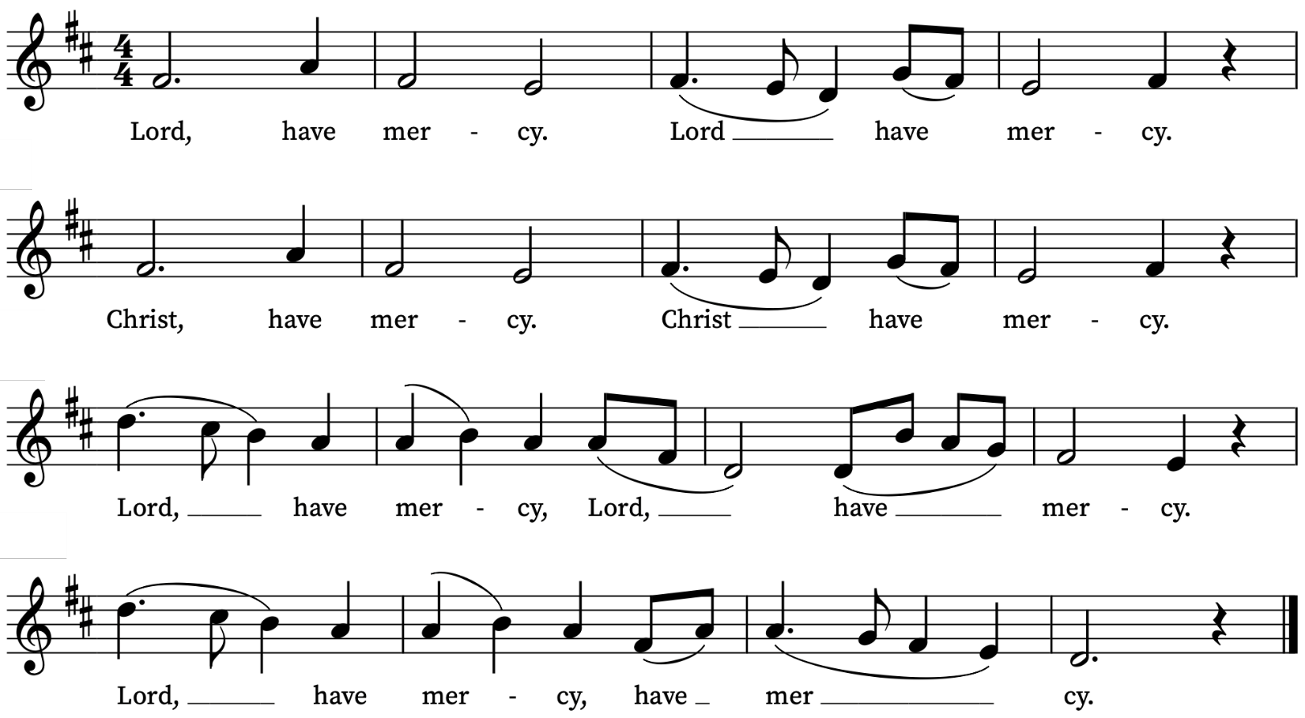
First Reading
Genesis 50: 15-21
A reading from the book of Genesis
Realizing that their father was dead, Joseph’s brothers said, ‘What if Joseph still bears a grudge against us and pays us back in full for all the wrong that we did to him?’ So they approached Joseph, saying, ‘Your father gave this instruction before he died, “Say to Joseph: I beg you, forgive the crime of your brothers and the wrong they did in harming you.” Now therefore please forgive the crime of the servants of the God of your father.’ Joseph wept when they spoke to him. Then his brothers also wept, fell down before him, and said, ‘We are here as your slaves.’ But Joseph said to them, ‘Do not be afraid! Am I in the place of God? Even though you intended to do harm to me, God intended it for good, in order to preserve a numerous people, as he is doing today. So have no fear; I myself will provide for you and your little ones.’ In this way he reassured them, speaking kindly to them.
This is the Word of the Lord
Thanks be to God
Psalm 103: 1-13
Benedic, anima mea
Praise the Lord, O my soul : and all that is within me praise his holy Name.
2 Praise the Lord, O my soul : and forget not all his benefits;
3 Who forgiveth all thy sin : and healeth all thine infirmities;
4 Who saveth thy life from destruction : and crowneth thee with mercy and loving-kindness;
5 Who satisfieth thy mouth with good things : making thee young and lusty as an eagle.
6 The Lord executeth righteousness and judgement : for all them that are oppressed with wrong.
7 He shewed his ways unto Moses : his works unto the children of Israel.
8 The Lord is full of compassion and mercy : long-suffering, and of great goodness.
9 He will not alway be chiding : neither keepeth he his anger for ever.
10 He hath not dealt with us after our sins : nor rewarded us according to our wickednesses.
11 For look how high the heaven is in comparison of the earth : so great is his mercy also toward them that fear him.
12 Look how wide also the east is from the west : so far hath he set our sins from us.
13 Yea, like as a father pitieth his own children : even so is the Lord merciful unto them that fear him.
Second Reading
Romans 14: 1-12
A reading from Paul’s Letter to the Romans
Welcome those who are weak in faith, but not for the purpose of quarrelling over opinions. Some believe in eating anything, while the weak eat only vegetables. Those who eat must not despise those who abstain, and those who abstain must not pass judgement on those who eat; for God has welcomed them. Who are you to pass judgement on servants of another? It is before their own lord that they stand or fall. And they will be upheld, for the Lord is able to make them stand.
Some judge one day to be better than another, while others judge all days to be alike. Let all be fully convinced in their own minds. Those who observe the day, observe it in honour of the Lord. Also those who eat, eat in honour of the Lord, since they give thanks to God; while those who abstain, abstain in honour of the Lord and give thanks to God.
We do not live to ourselves, and we do not die to ourselves. If we live, we live to the Lord, and if we die, we die to the Lord; so then, whether we live or whether we die, we are the Lord’s. For to this end Christ died and lived again, so that he might be Lord of both the dead and the living.
Why do you pass judgement on your brother or sister? Or you, why do you despise your brother or sister? For we will all stand before the judgement seat of God. For it is written,
‘As I live, says the Lord, every knee shall bow to me,
and every tongue shall give praise to God.’
So then, each of us will be accountable to God.
This is the Word of the Lord
Thanks be to God
Gospel Reading
Matthew 18: 21-35
Hear the Gospel of our Lord Jesus Christ according to Matthew
Glory be to thee, O Lord
Then Peter came and said to Jesus, ‘Lord, if another member of the church sins against me, how often should I forgive? As many as seven times?’ Jesus said to him, ‘Not seven times, but, I tell you, seventy-seven times.
‘For this reason the kingdom of heaven may be compared to a king who wished to settle accounts with his slaves. When he began the reckoning, one who owed him ten thousand talents was brought to him; and, as he could not pay, his lord ordered him to be sold, together with his wife and children and all his possessions, and payment to be made. So the slave fell on his knees before him, saying, “Have patience with me, and I will pay you everything.” And out of pity for him, the lord of that slave released him and forgave him the debt. But that same slave, as he went out, came upon one of his fellow-slaves who owed him a hundred denarii; and seizing him by the throat, he said, “Pay what you owe.” Then his fellow-slave fell down and pleaded with him, “Have patience with me, and I will pay you.” But he refused; then he went and threw him into prison until he should pay the debt. When his fellow-slaves saw what had happened, they were greatly distressed, and they went and reported to their lord all that had taken place. Then his lord summoned him and said to him, “You wicked slave! I forgave you all that debt because you pleaded with me. Should you not have had mercy on your fellow-slave, as I had mercy on you?” And in anger his lord handed him over to be tortured until he should pay his entire debt. So my heavenly Father will also do to every one of you, if you do not forgive your brother or sister from your heart.’
This is the Gospel of the Lord
Praise be to thee, O Christ
Today’s Music
Mass setting (Gloria, Sanctus/Benedictus, Agnus Dei):
Missa Tertia Octavi Toni – Giovanni Croce
Psalm 103: 1-13
You can find the words on page 3 of this sheet.
Anthem
Steal away from A Child of our Time - Michael Tippett
Steal away, steal away, steal away to Jesus;
Steal away, steal away home— I han't got long to stay here.
My Lord, He calls me, He calls me by the thunder,
The trumpet sounds within-a my soul, I han't got long to stay here.
Green trees a-bending, poor sinner stand a-trembling,
The trumpet sounds within-a my soul, I han't got long to stay here.
Steal away, steal away, steal away to Jesus;
Steal away, steal away home— I han't got long to stay here.
Communion Motet
Ave verum corpus – William Byrd
Ave, verum corpus natum  de Maria Virgine:  vere passum, immolatum  in cruce pro homine:  cuius latus perforatum  fluxit aqua et sanguine:  esto nobis praegustatum,  in mortis examine.  O Jesu dulcis, O Jesu pie,  O Jesu Fili Mariae.  Miserere mei. Amen. | Hail the true body, born  of the Virgin Mary: You who truly suffered and were sacrificed on the cross for the sake of man.  From whose pierced flank  flowed water and blood:  Be a foretaste for us  in the trial of death.  O sweet, O merciful,  O Jesus, Son of Mary.  Have mercy on me. Amen.  Medieval Latin hymn
Organ voluntary
Allegretto – Percy Whitlock
Prayers for the week
We pray for those in need: Colin Coveney, Fr Giles Harcourt, William Higginson, Carole Hubble, Marion Kokott, James Markham, Sara Mauleverer, Lylian Meira, Véronique Müller, Vernon Mustoe, Nicola Orme, Karen Robjont, Jean Smith, Geoff Staden, Tina Stanley, and Pauline Youll.
We remember those who have died recently including Myles Dove, Gilli Frewer, Joe Geshwiler, Nomsa Monareng, Maulene Sweet and John Yeomans. We also remember Tunji Abodunrin on his year’s mind. We ask God’s comfort on all who are mourning the loss of loved ones.
If you wish to add names to the prayers for those in need or departed please contact David McEvoy dmcevoy@btinternet.com
Supporting St Alfege Church
Please do make a gift to support the life and ministry of St Alfege Church – during the collection in the service or by using a card reader at the North and West Doors. Please complete a Gift Aid envelope (if you are eligible) whether you donate by cash or card. You can also use this QR code to donate. | 

Services this week
Sunday 13 September Fifteenth Sunday after Trinity
10.00am Parish Eucharist
Monday 14 September
8.30am Morning Prayer
Tuesday 15 September
8.30am Morning Prayer
Wednesday 16 September
8.30am Morning Prayer
Thursday 17 September
8.00am Holy Communion
Sunday 20 September Sixteenth Sunday after Trinity
8.00am Holy Communion
10.00am Sung Eucharist

Walk-in Wednesdays
Every Wednesday 10am-12noon in the small hall
Contact us
Vicar: Revd Simon Winn
Curate: Revd Dr Tati Gutteridge (on maternity leave)
Church Office: 020 8853 0687
Email: office@st-alfege.org.uk Website: www.st-alfege.org.uk
Safeguarding Team
Karen Hansen Lead Safeguarding Officer 07866 932 894
Carole Moses Safeguarding Officer 07889 396 671
Irene Bishop Safeguarding Officer 020 8698 2658
safeguarding@st-alfege.org.uk

