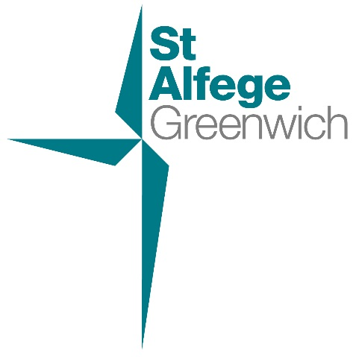

A Service of Prayer and Thanksgiving for the life of
HRH the Duke of Edinburgh
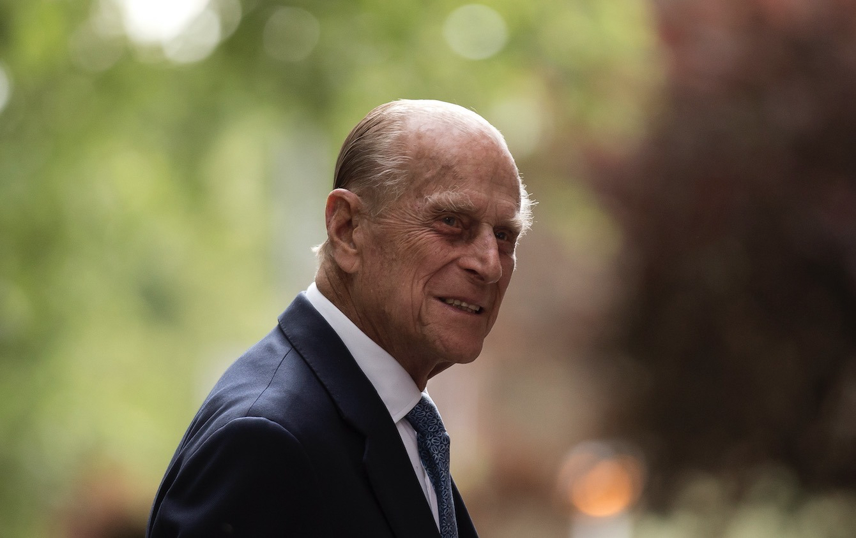
June 10th 1921- April 9th 2021

Sunday April 11th at 6.30pm
St Alfege Church, Greenwich

Welcome to our reflective service at which we give thanks for the life, faith, and service to country and Commonwealth of HRH Prince Philip, Duke of Edinburgh and Baron Greenwich. In the course of his long life Prince Philip made a number of close connections with Greenwich, its people, institutions and communities.
We are pleased to welcome to our worship Deputy Lieutenant for the Royal Borough of Greenwich Dr Pieter van der Merwe, The Worshipful the Mayor of the Royal Borough of Greenwich Cllr Linda Bird and Leader of the Council Cllr Danny Thorpe.
Regrettably, continuing pandemic restrictions mean the congregation cannot sing tonight. Our music is led by members of St Alfege choir, under Director of Music Stephen Dagg with assistant organist Ben Newlove.
Our service is led by the Vicar of St Alfege, the Revd Simon Winn and Assistant Priest, the Revd Caroline Risdon.

As the organ prelude concludes, please stand
Procession
Sentence, Welcome and Bidding Prayer
The choir sings
Contakion of the Dead
Give rest, O Christ, to thy servant with thy saints,
where sorrow and pain are no more;
neither sighing, but life everlasting.
Thou only art immortal,
the Creator and Maker of man;
and we are mortal, formed of the earth,
and unto earth shall we return;
for so thou didst ordain when thou createdst me, saying:
'Dust thou art, and unto dust shalt thou return.'
All we go down to the dust,
and, weeping o'er the grave we make our song:
Alleluia, alleluia, alleluia.
Give rest, O Christ,
to thy servant with thy saints,
where sorrow and pain are no more;
neither sighing, but life everlasting.
Words: Eastern Orthodox memorial Service, tr. WJ Birkbeck 1869-1916
Music: Kiev Melody
Reading Psalm 139: 1-14
Read by The Worshipful the Mayor of the Royal Borough of Greenwich Cllr Linda Bird
At the end: This is the Word of the Lord
All: Thanks be to God

Reading 1 Peter 1: 3-9
Read by Deputy Lieutenant for the Royal Borough of Greenwich Dr Pieter van der Merwe, MBE, DL
At the end: This is the Word of the Lord
All: Thanks be to God
Reflection The Revd Simon Winn
Two minutes’ silence
The choir sings
Let us now praise famous men
Let us now praise famous men,
And our Fathers that begat us.
Such as did bear rule in their kingdoms,
Men renowned for their power.
Leaders of the people
By their counsels and by their knowledge.
Such as found out musical tunes,
And recited verses in writing:
All these were honoured in their generations,
And were the glory of their times.
And some there be which have no memorial;
Who are perished, as though they had never been.
Their bodies are buried in peace;
But their name liveth for ever more.
Words: from Ecclesiasticus chapter 44
Music: Ralph Vaughan Williams (1872-1958)

Prayers The Revd Caroline Risdon
Including the responses:
Lord, have mercy upon us.
All: Christ, have mercy upon us.
Lord, have mercy upon us.
The Lord’s Prayer
Our Father, who art in heaven,
hallowed be thy name;
thy kingdom come;
thy will be done;
on earth as it is in heaven.
Give us this day our daily bread.
And forgive us our trespasses,
as we forgive those who trespass against us.
And lead us not into temptation;
but deliver us from evil.
For thine is the kingdom,
the power and the glory,
for ever and ever. Amen.
The souls of the righteous are in the hand of God,
All: And there shall no torment touch them.
You, Lord, have delivered my soul from death,
All: My eyes from tears and my feet from falling.
I will walk before the Lord
All: In the land of the living.

The choir sings
Salvator Mundi
O Saviour of the world, who by thy Cross and thy precious Blood hast redeemed us, save us and help us, we humbly beseech thee, O Lord.
Words: Antiphon for matins on the Feast of the Exultation
of the Cross
Music: from Requiem by Herbert Howells (1892-1983)
Prayer of Commendation
Blessing
The choir sings
The National Anthem (1st verse)
You are invited to pause to light a candle before you leave church - please exit by the south or west doors.
Organ postlude: 'Nimrod' from Enigma Variations by Edward Elgar (1857-1934)

You can find information about our regular services
and opening times on our website:
www.st-alfege.org.uk

